Electricity II

Remember to photocopy 4 pages onto one sheet by going A3→A4 AND back to back on the photocopier

Student name: ________________________________

This booklet contains every higher and ordinary level question that has appeared on an exam paper on this topic from 2002–2023
Worked solutions to Ordinary Level Maths questions can be found at the end of the booklet.
Fully worked solutions to all higher level past papers can be found on the homepage of thephysicsteacher.ie

Screencasts of all topics plus a wide range of other resources via this link

You can find this document plus all other booklets on the homepage of thephysicsteacher.ie
Last updated: 04/08/2024
Noel Cunningham
Contents
1. Potential difference 3
Measuring potential difference 4
Electromotive force (emf) 4
Extra reading 5
2: Current and Charge 6
Conventional current 7
Measuring current 7
3: Resistance 9
Resistors in series 11
Resistors in parallel 11
Electric circuits maths problems 13
18
The multimeter 18
Resistivity 19
The rheostat 20
The potential divider circuit 23
The potentiometer 23
The Wheatstone bridge 24
The metre bridge 26
TO INVESTIGATE THE VARIATION OF CURRENT WITH POTENTIAL DIFFERENCE FOR A FILAMENT BULB 27
TO INVESTIGATE THE VARIATION OF CURRENT WITH POTENTIAL DIFFERENCE FOR A METALLIC CONDUCTOR 31
TO MEASURE THE RESISTIVITY OF THE MATERIAL OF A WIRE 33
TO INVESTIGATE THE VARIATION OF RESISTANCE OF A METALLIC CONDUCTOR WITH TEMPERATURE 37
SLOP 41
4. Effects of an electric current and domestic circuits 42
The magnetic effect of an electric current 42
The chemical effect of an electric current 42
The heating effect of an electric current 43
Relationship between work, current, resistance and time 43
Joule’s Law 43
Why is electrical energy transmitted using high voltage power lines? 44
Domestic electric circuits 45
The kilowatt-hour 47
Relationship between current and voltage for different conductors 48
TO INVESTIGATE THE VARIATION OF POTENTIAL DIFFERENCE WITH CURRENT FOR COPPER ELECTRODES IN A COPPER-SULPHATE SOLUTION 50
TO VERIFY JOULE’S LAW 54
SLOP 58
VOLTAGE, CURRENT AND RESISTANCE EXAM QUESTIONS 2002 – 2023 60
Electric circuits – maths questions 60
Resistivity 65
Wheatstone bridge and metre bridge 67
Effects of an electric current: Ordinary level questions 69
Voltage-current graphs for different conductors 72
Effects of an electric current: Higher level questions 74
EXAM SOLUTIONS: ORDINARY LEVEL MATHS QUESTIONS 76

1. Potential difference

Student Notes

The most important equation in electricity is arguably the following which details the relationship between work, potential difference and charge:

$$W = VQ$$

Electrical power, potential difference and current

We have seen that power is defined as the rate at which work is done or power is the rate at which energy is converted from one form to another.

Now if we take W = VQ and divide both sides by time we get P = VI (because $P=\frac{w}{t}$, and $I=\frac{Q}{t}$)

$$P = VI$$

Related exam questions
2010 Question 8 [Higher Level]  An electric heater has a power rating of 2 kW when connected to the ESB mains supply of 230 V.  Calculate the current that flows through the heater. | P = 2 kW = 2000 W V = 230 V  P = VI ⇒ I = P ÷ V = 2000 ÷ 230  ⇒ I = 8.7 A
A table lamp has a power rating of 100 W and 230 V. Calculate the current that flows through the lamp. | P = 100 W V = 230 V  P = VI ⇒ I = P ÷ V = 100 ÷ 230  P = 0.43 A
2002 Question 8 [Higher Level]  The ESB supplies electrical energy at a rate of 2 MW to an industrial park from a local power station, whose output voltage is 10 kV.  Calculate the current. | P = 2 MW = 2 × 10⁶ W  V = 10 kV = 10000 V  P = VI  I = P ÷ V  I = (2 × 10⁶) ÷ (10000) = 200 A

Measuring potential difference

- Voltages in series: V_{Total} = V₁ + V₂
- Voltages in parallel are the same.
- A voltmeter is used to measure potential difference.
- A voltmeter is always connected in parallel with whatever it is measuring.

Draw a diagram to show how two light bulbs can be connected in parallel to a battery. | 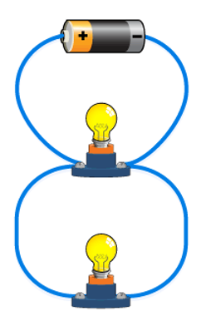  Solution

Electromotive force (emf)
A voltage when applied to a full circuit is called an emf.
The unit of emf is therefore also the volt.

Extra reading

We have noted already that one way of defining potential difference is by saying it is the work done when bringing a charge from one point to another. This suggests that something has to do work on the charge.
But this is only if the charge in question is similar in sign to the sign of the charge it is going to, e.g. electron to negative terminal, or proton to positive terminal. Alternatively we could define potential difference as the work done by the charge in going from one place to another, e.g. an electron moving towards a positive terminal.

But what does it mean to say that ‘the charge is doing work’? Work is a form of energy, so the charge must be converting energy from one form to another (anytime work is being done, energy is being converted from one form to another). In this case potential energy is being converted to kinetic energy (the charge speeds up), and when the charge reaches the terminal this kinetic energy gets converted in to a combination of heat and/or chemical energy. Remember the relationship W = VQ? This can be rearranged to give V = W/Q, which in physical terms means that the potential difference between two points can be defined as the work done as the charge goes from one point to the other divided by the charge itself.

Don’t be too surprised if you find this stuff confusing. Not only is it difficult to understand an abstract concept (it’s not like you can hold a bunch of voltage in your hand), but the meaning of the term ‘voltage’ has itself changed over the years, and you’re left to make sense of the remaining muddle! If you think I’m just saying this to make you feel better, then read on.

The following extract has been taken from the minutes of a History of Science meeting, in 2000.
John Roche, of Linacre College, Oxford, opened the session after tea, speaking on the concept of voltage. He began by claiming that almost every concept in electricity and electromagnetism is ambiguous, and the concept of voltage is one of the most incoherent. Its evolution in difficult to follow.
Abbé Nollet, in the 18th century, distinguished quantity and degree of electrification. Others made similar distinctions between quantity and intensity or tension or pressure – what we would call voltage.
Roche showed how the term “voltage” had come to be used nowadays in three different ways; for electromotive force, potential difference and (absolute) potential.
Volta defined electrical tension as the endeavour of the electrical fluid to escape from a body. Volta’s tension was more akin to a force, unlike the modern definition of electromotive force, which is a misnomer, being defined in terms of energy.
Ohm carried Volta’s concept to closed circuits with the idea that voltage was proportional to the difference in tension between the ends of a conductor. For Ohm, it was the gradient of electrical tension that drove the current.
Poisson introduced an entirely different concept, of charge divided by distance to a point, which Green called the potential. This was an analytical device only, arising from an analogy with Laplace’s gravitational potential function.
Kirchhoff reconciled Volta’s tension with Poisson’s potential function through the concept of energy or vis viva introduced by Helmholtz. From Kirchhoff, current is driven by the electric field in a conductor and voltage is related to the energy supplied, but physicists and electrical engineers do not usually think of them in this way.
All the earlier interpretations remain current, but with different weights, and most of the time voltage is seen as a driving energy.
IOP History of Physics Group Newsletter, Spring 2000, page 65

2: Current and Charge

Student Notes
Conductors and insulators
A conductor is a substance which allows charge to flow through it easily.
An insulator is a substance which does not allow charge to flow through it easily.

To test if a material is a conductor or an insulator
- Set up the circuit as shown.
Label | Circuit component
A | Switch
B | Power supply
C | Resistor
D | Bulb

- Place various different materials between points X and Y in the circuit and turn on the switch.

- If the bulb lights then the material is a conductor and if it doesn’t then the material is an insulator.

Electric current
Electric current is a measure of the rate of flow of charge.
$$I=\frac{Q}{t}$$
Mathematically

The symbol for current is I
The unit of electric current is the ampere or amp (A).

From this we can see that the ampere is equivalent to 1 coulomb per second (1 A = 1 C s⁻¹).
Rearranging this gives: amount of charge flowing past a point = current flowing through it × time
Q = It
The coulomb is the amount of charge that passes when a current of one amp flows for one second.

Conventional current
Conventional current is current which is represented as going from positive to negative, whereas in reality (for a metal) it is actually the negative electrons which are going from the negative terminal to the positive.
Thank you Benjamin Franklin.

Measuring current
- Current is measured with an ammeter.
- An ammeter must be connected in series with that part of the circuit through which the current is flowing.
- The current is the same at every point in a series circuit.
- The sum of the currents flowing into a junction is equal to the sum of the currents leaving the junction.

2022 Question 11 [Ordinary Level]  A torch contains a battery, a light bulb and a switch.  Draw a circuit diagram to show how these components are connected in a torch.  You may refer to the electrical circuit symbols on pages 72 to 78 of the booklet of Formulae and Tables.) | 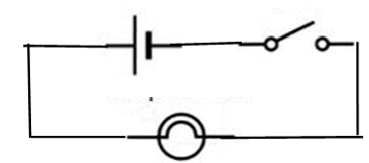  Solution

Related exam question
2010 Question 8 [Higher Level]
A hair dryer with a plastic casing uses a coiled wire as a heat source.
When an electric current flows through the coiled wire, the air around it heats up and a motorised fan blows the hot air out.
- The diagram shows a basic electrical circuit for a hair dryer.
Describe what happens when switch A is closed and the rheostat is adjusted
- Describe what happens when switch A and switch B are closed.

Solution
- When switch A is closed then the circuit on the left is complete so current will flow, so the fan will start to turn blowing air out of the fan.
- Now if we then close switch B current will run through the coil heating it up, so now the air coming out of the fan will pass through the hot coil and therefore heat up as it leaves the hairdryer.

Review of electrical symbols and units

Quantity | Symbol | Unit | Symbol of unit
Charge | Q | Coulombs | C
Current | I | Amps | A

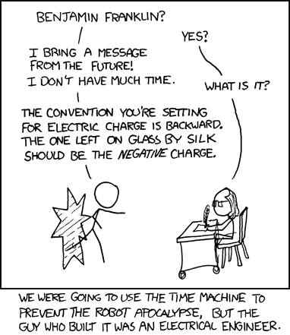

3: Resistance
Something to think about
- Consider a simple circuit with just a battery and a 4 Ω resistor arranged in series. Now add a second resistor (of the same value) in parallel to the first resistor. Does the overall current in the circuit go up, down or remain the same?

- What speed do electrons move at in an electric circuit?

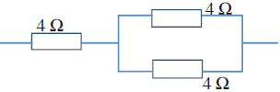
- An electron in a circuit gets to a junction where it can go left or right. How does it decide which way to go? It seems like a silly question but just like Calvin’s question about ice floating, the discussion can often lead to deeper understanding so it’s well worth persisting with it. And don’t let dad’s (or mom’s) lack of interest put you off.
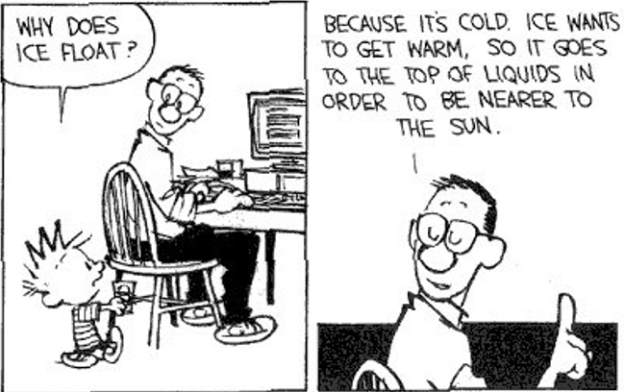

Student Notes
Resistance
As electrons move through a metal, the metal resists this movement. The electrons collide with atoms of the metal and lose kinetic energy - this energy is converted into heat. This happens more in some metals than in others – this leads us to our definition of resistance.

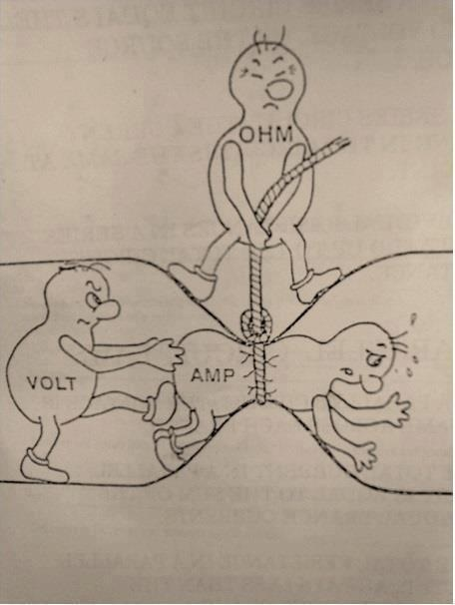
The resistance of a conductor is the ratio of the potential difference across it to the current flowing through it.

$R= \frac{V}{I}$
Mathematically:

The unit of resistance is the ohm
The symbol for the ohm is Ω

Ohm’s Law states that the current flowing through a conductor is directly proportional to the potential difference across it, assuming constant temperature.

Note that Ohm’s law only applies to certain substances.

Introduction to circuit diagrams
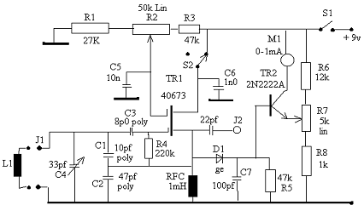
Circuit diagrams are two-dimensional drawings of electronic circuits rather like architectural plans for a building or a map for a metro system. We use symbols to represent each component. See pages 72 – 77 of the Formulae & Tables booklet for common circuit symbols however over time you will (or should) become familiar with the most common components.

Derivation of formulae for resistors in series and in parallel

Resistors in series
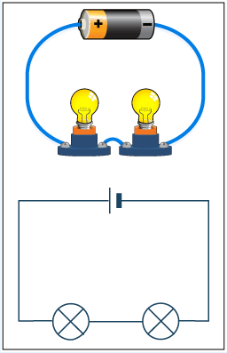
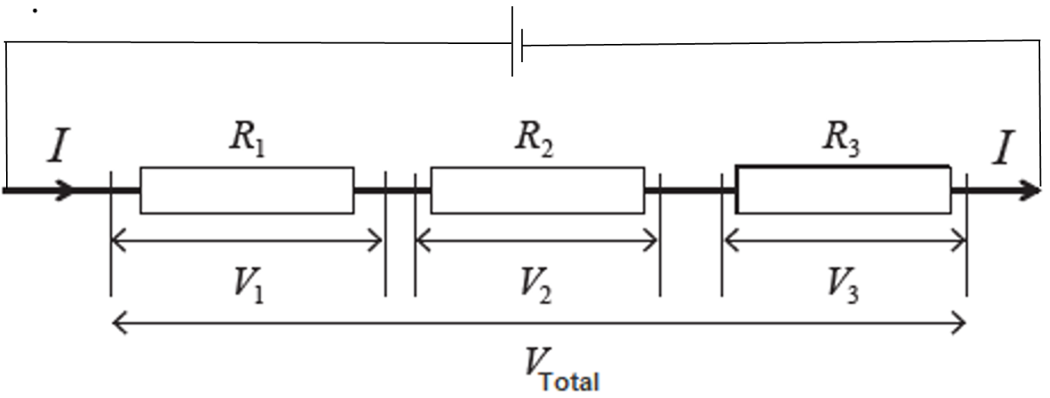

Derivation
We know that for voltages in series: V_{Total} = V₁ + V₂ + V₃

But V = IR (Ohm’s Law)

⇒ IR_{Total} = IR₁ + IR₂ + IR₃

We can now cancel the I’s because the current is the same for resistors in series

⇒ R_{Total} = R₁ + R₂ + R₃

Resistors in parallel
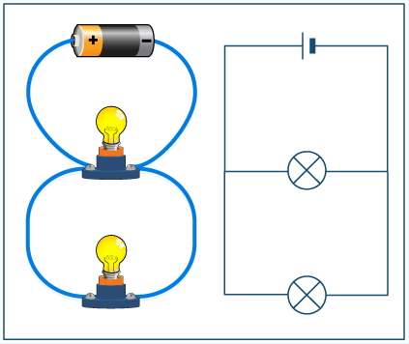
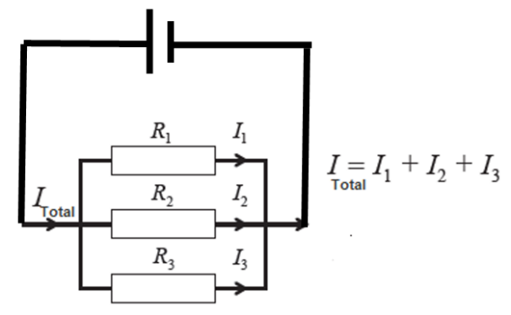

Derivation

We know that for currents in parallel I_{Total} = I₁ + I₂+ I₃

But $I=\frac{ V}{R}$ (Ohm’s Law) ⇒ $\frac{V_{T}}{R_{Total}}= \frac{V_{1}}{R_{1}}+ \frac{V_{2}}{R_{2}}+ \frac{V_{3}}{R_{3}}$

We can now cancel the V’s because the voltage is the same for resistors in parallel

⇒ $\frac{1}{R_{Total}}= \frac{1}{R_{1}}+ \frac{1}{R_{2}}+ \frac{1}{R_{3}}$

Calculating effective resistance– exam questions

2015 Question 5 [Higher Level]  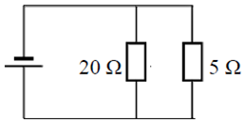  Calculate the effective resistance of the resistors shown in this circuit diagram. | $\frac{1}{R_{Total}}= \frac{1}{R_{1}}+ \frac{1}{R_{2}}$ $\frac{1}{R_{Total}}= \frac{1}{20}+ \frac{1}{5}$  $\frac{1}{R_{Total}}= \frac{5}{20}$ R_{Total} = 4 Ω
2018 Question 5 [Higher Level]  Calculate the effective resistance of a 5 Ω resistor and a 7 Ω resistor when they are connected in parallel. | $\frac{1}{R_{Total}}= \frac{1}{R_{1}}+ \frac{1}{R_{2}}$ $\frac{1}{R_{Total}}= \frac{1}{5}+ \frac{1}{7}$  $\frac{1}{R_{Total}}= \frac{12}{35}$ R_{Total} = 2.9 Ω
2012 Question 9 [Higher Level]  Two 4 Ω resistors are connected in parallel.  Draw a circuit diagram to show how another 4 Ω resistor could be arranged with these two resistors to give an effective resistance of 6 Ω. | $\frac{1}{R_{parallel}}= \frac{1}{4}+ \frac{1}{4}$ $\frac{1}{R_{parallel}}= \frac{2}{4}$ R_{parallel} = 2 Ω  So we need a another resistor in series whose resistance is 4 Ω.

Electric circuits maths problems
When using any of the following; V = RI, $I=\frac{V}{R}$ or $R=\frac{V}{I}$ note that the potential difference must correspond to the potential difference across that resistor and the current must correspond to the current flowing through that resistor.
You must follow the following steps:

Step 1: Find the total resistance flowing in the circuit
To find total resistance you must remember the rules for adding resistors in series and in parallel.

Step 2: Note the total voltage; you are usually told this directly.

Step 3: Find the total current flowing in the circuit using $I_{Total}=\frac{V_{Total}}{R_{Total}}$

2020 Question 12 (c) [Ordinary Level]  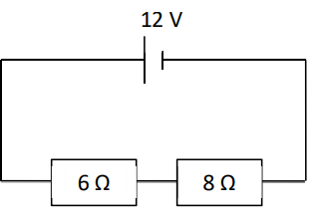  - Calculate the total resistance in the circuit shown.  - Calculate the current flowing in the circuit. | Total resistance  R_{total} = R₁ + R₂ = 6 + 8 = 14 Ω  Total voltage: 12 V  Total current flowing in the circuit  $I_{Total}=\frac{V_{Total}}{R_{Total}}= \frac{12}{14}$ = 0.86 A
2007 Question 12 (c) [Ordinary Level]  - Calculate the total resistance of the circuit.  - Calculate the current in the circuit.  - Calculate the potential difference across the 9 Ω resistor. | Total resistance  R_{total} = R₁ + R₂ = 3 + 9 = 12 Ω  Total voltage: 6 V  Total current flowing in the circuit  $I_{Total}=\frac{V_{Total}}{R_{Total}}= \frac{6}{12}$ = 0.5 A  9 Ω resistor  V_{9Ω} = R_{9Ω}I_{9Ω} = (9)(0.5) = 4.5 V
2018 Question 9 (c) [Ordinary Level]  Calculate the total resistance of the circuit.  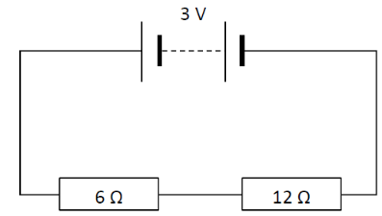  - Calculate the current in the circuit.  - Calculate the potential difference across the 6 Ω resistor. | Total resistance  R_{total} = R₁ + R₂ = 6 + 12 = 18 Ω  Total voltage: 3 V  Total current flowing in the circuit  $I_{Total}=\frac{V_{Total}}{R_{Total}}= \frac{3}{18}$ = 0.17 A  6 Ω resistor  V_{6Ω} = R_{6Ω}I_{9Ω} = (6)(0.17) = 1.02 V
Note about worked solution above
- We rounded the total current up to 0.17 A. If we kept the correct answer in our calculator and used that to calculate the potential difference across the 6 Ω resistor we would get an answer of 1.0 V.
- The potential difference across the 12 Ω resistor will be twice the potential difference across the 6 Ω resistor so we could just have split up the total potential difference in the ratio 2:1 to get the same answer.
Watch out!!! Remember that if $\frac{1}{R_{total}}=\frac{1}{2}$ then R_{Total} = 2 Ω

2002 Question 8 [Ordinary Level]  A circuit consists of a 3 Ω resistor and a 6 Ω resistor connected in parallel to a 1.5 V d.c. supply as shown.  - Calculate the total resistance of the two resistors.  - Calculate the current flowing in the circuit.  - What is the current in the 3 Ω resistor? | Total resistance  $\frac{1}{R_{parallel}}= \frac{1}{3}+ \frac{1}{6}$ $\frac{1}{R_{parallel}}= \frac{3}{6}$ R_{parallel} = 2 Ω  Total voltage: 1.5 V  Total current flowing in the circuit  $I_{Total}=\frac{V_{Total}}{R_{Total}}= \frac{1.5}{2}$ = 0.75 A  Current flowing through 3 Ω resistor  $I_{3 Ω }=\frac{V_{3Ω}}{R_{3Ω}}= \frac{1.5}{3}$ = 0.5 A
Note about worked solution above
- This is where it starts to get a bit funny. Remember where we said that voltages in parallel were the same? Well the 1.5 V supply voltage (or potential difference or e.m.f) is in parallel with the 3 Ω and 6 Ω resistors so they all have a potential difference of 1.5 V.
- In case the total current will be split between the 3 Ω and 6 Ω resistors in the ratio of their resistances, i.e. 3:6 or 1:2. The only danger with this approach is that the temptation is to associate the higher voltage with the higher resistance when in fact it has to be the other way around. This is why I avoid this approach – but it’s completely up to you 😊

2016 Question 8 [Ordinary Level]  The diagram above shows a circuit with a 12 V d.c. power supply, an ammeter, and two 4 Ω resistors connected in parallel.  - Calculate the total resistance of the circuit  - Calculate the current flowing through the ammeter  - Calculate the current flowing through each resistor. | Total resistance  $\frac{1}{R_{parallel}}= \frac{1}{4}+ \frac{1}{4}$ $\frac{1}{R_{parallel}}= \frac{2}{4}$ R_{parallel} = 2 Ω  Total voltage: 12 V  Total current flowing in the circuit  $I_{Total}=\frac{V_{Total}}{R_{Total}}= \frac{12}{2}$ = 6 A. This will also flow through the ammeter.  Current flowing through each 4 Ω resistor  $I_{4Ω }=\frac{V_{4Ω}}{R_{4Ω}}= \frac{12}{4}$ = 3 A  Or you could have simply assumed that the total current of 6 A gets split evenly between both resistors.
2008 Question 9 [Ordinary Level]  - The two headlights of a truck are connected in parallel to a 24 V supply.  Draw a circuit diagram to show how the headlights are connected to the supply.  - The resistance of each headlight is 20 Ω.  Calculate the total resistance in the circuit.  - Calculate the current flowing in the circuit. | Total resistance  $\frac{1}{R_{parallel}}= \frac{1}{20}+ \frac{1}{20}$ $\frac{1}{R_{parallel}}= \frac{2}{20}$ R_{parallel} = 10 Ω  Total voltage: 24 V  Total current flowing in the circuit  $I_{Total}=\frac{V_{Total}}{R_{Total}}= \frac{24}{10}$ = 2.4 A.
2022 Question 9 (c) [Higher level]  Three resistors X, Y and Z are arranged in a circuit as shown below.  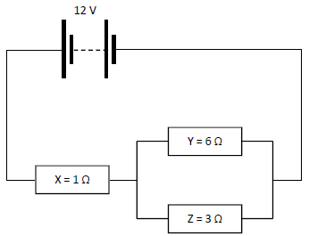  - Calculate the current flowing in the 1 Ω resistor.  - Calculate the current flowing in the 6 Ω resistor. | Total resistance  $\frac{1}{R_{parallel}}= \frac{1}{6}+ \frac{1}{3}$ $\frac{1}{R_{parallel}}= \frac{3}{6}$ R_{parallel} = 2 Ω  We now have to add the 1 Ω resistor which is in series to give a total resistance of 3 Ω  Total voltage: 12 V  Total current flowing in the circuit  $I_{Total}=\frac{V_{Total}}{R_{Total}}= \frac{12}{3}$ = 4 A.  Current flowing through the 1 Ω resistor  The total current of 4 A will also flow through the 1 Ω resistor.  Current flowing through the 6 Ω resistor  Here we will go with the ratios method:  The total current of 4 A will split up in the ratio 6:3 or 2:1, so the current through the 6 Ω resistor will be one third of total current and the current through the 3 Ω resistor will be two thirds of total current.  Current through the 6 Ω resistor = 1.33 A

2021 Question 9 [Ordinary Level]  Examine the circuit diagram shown.  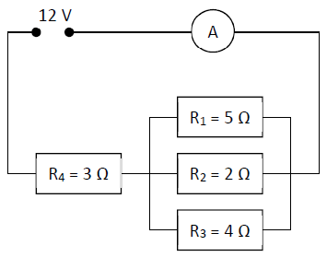  - Show that the combined resistance of the three resistors in parallel  (i.e. resistors R₁, R₂ and R₃) is 1.05 Ω.  - Calculate the total resistance in the circuit.  - Calculate the current flowing through the ammeter, A. | Total resistance  $\frac{1}{R_{parallel}}= \frac{1}{5}+ \frac{1}{2}+\frac{1}{4}$  $\frac{1}{R_{parallel}}= \frac{4+10+5}{20}=\frac{19}{20}$  $R_{parallel}=\frac{20}{19}=1.05 Ω$  Total resistance = 1.05 + 3 = 4.05 Ω  Total voltage: 12 V  Total current flowing in the circuit  $I_{Total}=\frac{V_{Total}}{R_{Total}}= \frac{12}{4.05}$ = 2.96 A.
2022 Question 11 [Ordinary Level]  - A charge of 30 C passes through a wire in a time of 6 s. Calculate the current flowing in the wire.  - The wire has a resistance of 3 Ω. Calculate the potential difference (voltage) across the wire.  - The 3 Ω wire is connected in parallel with another wire of resistance 2 Ω.  Calculate the total resistance of the two wires in parallel. | Solution  Part (i)  $I= \frac{Q}{t}=\frac{30}{6}$ = 5 Amps  Part (ii)  R = 3 Ω I = 5 A V = ?  V = RI = (3)(5) = 15 V  Part (iii)  $\frac{1}{R_{parallel}}= \frac{1}{3}+ \frac{1}{2}$ = $\frac{5}{6}$ $R_{parallel=}\frac{6}{5}$ = 1.2 Ω

2010 Question 9 (b) [Ordinary Level] {edited}
The diagram shows a number of resistors connected to a 12 V battery and a bulb of resistance is 4 Ω.
- Calculate the combined resistance of the 15 Ω and 30 Ω resistors in parallel.
- Calculate the total resistance of the circuit
- Calculate the current flowing in the circuit

Let’s assume that the question went on to ask us to calculate the potential difference across each resistor and the current flowing through each resistor.

Solution

(i) Resistance of two resistors in parallel
$\frac{1}{R_{parallel}}= \frac{1}{15}+ \frac{1}{30}$ $\frac{1}{R_{parallel}}= \frac{3}{30}$ R_{parallel} = 10 Ω

(ii) Total resistance
We now have to add the 10 Ω resistor and the resistance of the bulb (4 Ω). These are all in series so we can just add them directly to give a total resistance of 24 Ω.

(iii) Total current flowing in the circuit

Total voltage: 12 V $I_{Total}=\frac{V_{Total}}{R_{Total}}= \frac{12}{24}$ = 0.5A.

Calculate the potential difference across each resistor and the current flowing through each resistor.
The trick here is to begin by looking at the isolated resistor(s):

10 Ω resistor: I = 0.5 A R = 10 Ω V = IR = (0.5)(10) = 5 volts

Lightbulb (4 Ω): I = 0.5 A R = 4 Ω V = IR = (0.5)(4) = 2 volts

Finally let’s look at resistors in parallel
Voltage across resistors in parallel = 12 – (5 + 2) = 5 volts therefore the potential difference across both the 15 Ω and the 30 Ω resistors is 5 V.

To find I we use $I_{ }=\frac{V}{R}$ $I_{15Ω }=\frac{V_{15Ω}}{R_{15Ω}}= \frac{5}{15}$ = 0.33 A $I_{30Ω }=\frac{V_{30Ω}}{R_{30Ω}}= \frac{5}{30}$ = 0.17 A

Notes
- The current through the 15 Ω resistor plus the 30 Ω resistor adds up to 0.5 A, which was the current going in (or total current).

- You could have used ratios to split up the current: 30 is twice 15 so 2/3 of the total current goes through the 15 Ω resistor while 1/3 goes through the 30 Ω resistor.

2017 Question 8 [Higher Level]
Ignore the reference to a.c.; not relevant here.
In the circuit diagram shown the variable resistor is set at 500 Ω.
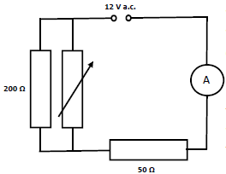
- Calculate the effective resistance of the circuit
- Calculate the current flowing in the 200 Ω resistor.
- The variable resistor is then removed.
What effect will this have on the current flowing in the 50 Ω resistor?
- Explain your answer.

- Calculate the effective resistance of the circuit

Note that the term ‘effective resistance’ is equivalent to the term ‘total resistance in this context.
$\frac{1}{R_{Total}}= \frac{1}{R_{1}}+ \frac{1}{R_{2}}$ $\frac{1}{R_{Total}}= \frac{1}{200}+ \frac{1}{500}$
R_{P} = 143 Ω R_{Total} = 143 + 50 = 193 Ω
- Calculate the current flowing in the 200 Ω resistor.
Look for the isolated resistor – which in this case is the 50 Ω resistor:
I = 0.062 A R = 50 Ω
V = IR = (0.062)(50) = 3.1 volts

Now if we subtract this voltage from the total voltage we can find the voltage across the resistors in parallel.

Voltage across the two resistors in parallel = 12 – 3.1 = 8.9 V
Therefore the potential difference across the 15 Ω and the 30 Ω resistors is 8.9 volts.

$I_{200Ω }=\frac{V_{200Ω}}{R_{200Ω}}= \frac{8.9}{200}$ = 0.045 A

- What effect will this have on the current flowing in the 50 Ω resistor?
The overall current will reduce
- Explain your answer.
Resistance of circuit is now greater.
You could work this out mathematically if you were so inclined. Alternatively you could just point out there is now one less path for the current to flow through.

The multimeter

A multimeter is an electrical instrument which can be used to measure voltage, current or resistance.

Resistivity

It can be demonstrated experimentally that the resistance of a material is proportional to the length: ⇒ R ∝ l
and inversely proportional to the cross-sectional area (C.S.A.) ⇒ $R \frac{1}{A}$ Putting this together ⇒ $R \frac{L}{A}$ ⇒ $R=k \frac{L}{A}$
The proportional constant is given the symbol ρ (pronounced ‘rho’– same as for density): $R= \frac{ρL}{A}$
Cross-multiplying to make ρ the subject of the formula:
$$ρ=\frac{RA}{L}$$
Formula for resistivity:

Resistivity is defined as the resistance of a material of unit length and unit cross sectional area.

Or Resistivity is defined as the resistance of a cube of material of side one metre.
The unit of resistivity is the ohm meter (Ω m). Use the formula above to work out why.

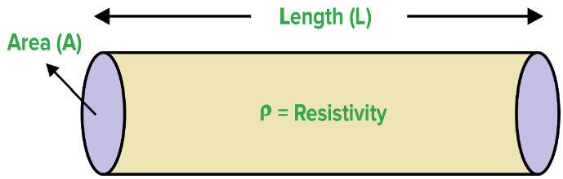
All of our maths questions on resistivity deal with a conducting wire. The cross-sectional area of a wire is a circle (see image) and the formula for the area of a circle is πr².

2022 Question 11 [Ordinary Level]
A piece of wire of length 1.5 m has a resistance of 12 Ω.
What is the resistance of a 3 m piece of the same wire?

R ∝ l so if the length increases by a factor of 2 (“doubles”) then the resistance will also increase by a factor of 2.
New resistance = 2 × 1.2 = 2.4 Ω

2014 Question 10 [Higher Level]
The radius of a wire is doubled. What is the effect of this on the resistance of the wire?

Solution
$ρ=\frac{RA}{L}$ ⇒ $R=\frac{ρL}{A}$ ⇒ $R=\frac{ρL}{πr^{2}}$ ⇒ $R∝\frac{1}{r^{2}}$
So if the radius increases by a factor of 2 (“doubles”) then the resistance will decrease by a factor of 4 (resistance gets 4 times smaller).
2017 Question 8
What is the effect on the resistance of a length of wire if the diameter of the wire is increased by a factor of three?
The cross-sectional area A of a wire = πr² = π${(\frac{d}{2})}^{2}$
So area is proportional to the square of the diameter.
So if the diameter goes up by a factor of 3, the area will go up by a factor of 9.

Now what’s the relationship between resistance and area?
So R is inversely proportional to A.
So if the area goes up by a factor of the 9 the resistance will go down by a factor of 9 (get 9 times smaller)
Answer: The resistance decreases by a factor of 9

Nice way to show that resistance depends on length – conducting putty
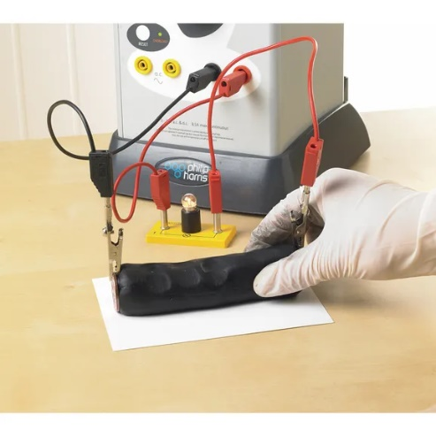

The rheostat
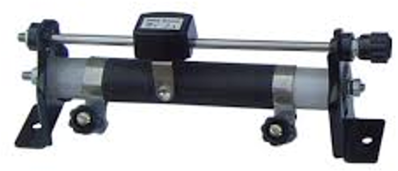
The photograph shows a rheostat, which is a variable resistor.
When the sliding contact is moved, the current flows through a different length of wire, thus changing the resistance of the rheostat.

How it works
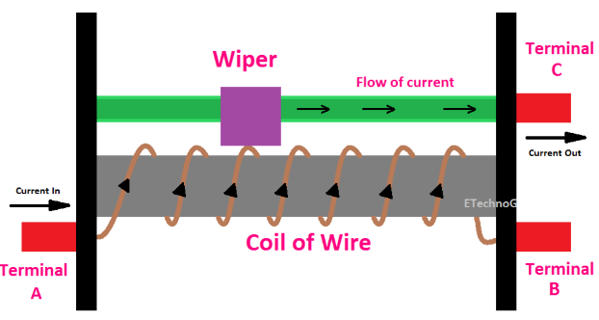
- The coil of wire (at the bottom) has a relatively high resistance whereas the metal bar on top has negligible resistance.
- Current goes in via terminal A and out via terminal C.
- The sliding contact (‘wiper’) acts as a bridge between the coil of wire and the metal bar and can move over and back along the top.
- The more of the wire that the current has to go through, the greater the resistance.

Resistivity: exam questions
2021 Question 9 [Ordinary Level]  A 4.8 m length of circular nichrome wire has a radius of 0.2 mm.  Nichrome has a resistivity of 1.1 × 10⁻⁶ Ω m.  - Calculate the circular cross‐sectional area of the wire.  - Calculate the resistance of the wire. | r = 0.2 mm = 0.2 × 10⁻³ m L = 4.8 m  ρ = 1.1 × 10⁻⁶ Ω m.  $Area=πr^{2}=π({0.2×{10}^{-3})}^{2}$ = 1.2566 × 10⁻⁷ m²  $R=\frac{ρL}{A}=\frac{(1.1×{10}^{-6})(4.8)}{1.2566×{10}^{-7}}$ = 42 Ω
2022 Question 5 [Higher Level]  A tungsten cube of side 2 cm has a resistance of 2.8 μΩ.  Calculate the resistivity of tungsten. | R = 2.8 × 10⁻⁶ Ω, L = 0.02 m, A = 0.02² m²  $ρ=\frac{RA}{L}= \frac{({2.8×10}^{-6})({0.02}^{2})}{0.02}$ = 5.6 × 10^{–8} Ω m
2002 Question 8 [Higher Level]  The total length of the cables connecting the industrial park to the power station is 15 km.  The cables have a diameter of 10 mm and are made from a material of resistivity 5.0 × 10⁻⁸ Ω m.  Calculate the total resistance of the cables. | L = 15000 m, r = 5 mm = 0.005 m  ρ = 5.0 × 10⁻⁸ Ω m  A = πr² = π(0.005)² = 7.85 × 10⁻⁵ m²  $R=\frac{L}{A}$ $R=\frac{(5.0 × {10}^{-8})(15000) }{7.85 × {10}^{-5}}$  ⇒ R = 9.6 Ω
2013 Question 8 (b) [Higher Level]  A 3 km length of aluminium wire has a circular cross-section of diameter 18 mm.  Calculate the resistance of the aluminium wire.  (resistivity of aluminium = 2.8 × 10⁻⁸ Ω m) | Diameter = 18 mm r = 9 mm = 9 × 10⁻³ m  $A= πr^{2}=π$(9 × 10⁻³)²  ρ= 2.8 × 10⁻⁸ Ω m, l = 3 km = 3000 m  $R=\frac{L}{A}$ $R= \frac{(2.8 × {10}^{-8})(3000)}{π(9 × {10}^{-3})^{2}}$  $R=0.33$ Ω
2008 Question 7 [Higher Level]  A heating coil has a resistance of 12 Ω, is 40 m long and it has a circular cross-section of diameter 2.2 mm.  Calculate the resistivity of nichrome. | Diameter = 2.2 mm, r = 1.1 mm = 1.1 × 10⁻³ m  R = 12 Ω, L = 40 m  A = πr² = π (1.1 × 10⁻³)² = 3.80 × 10⁻⁶ m²  $=\frac{RA}{l}$ $=\frac{\left(12\right)\left(3.80 × {10}^{-6}\right)}{40}$ ρ = 1.14 × 10⁻⁶ Ω m
2010 Question 8 [Higher Level]  A length of nichrome wire of diameter 0.17 mm has a resistance of 26.4 Ω.  Calculate the length of the coil of wire.  (resistivity of nichrome = 1.1 × 10^{–6} Ω m) | Diameter = 0.17 mm, r = 0.085 mm  = 0.085 × 10⁻³ m  A = πr² = (π)(0.085 × 10⁻³)² = 2.27 × 10⁻⁸ m²  ρ = $\frac{RA}{L}$ l = $\frac{RA}{ρ}$  L = $\frac{(26.4)( 2.27 ×{10}^{-8})}{1.1 ×{10}^{-6} }$ L = 0.545 m
2011 Question 12 (c) [Higher Level]  1 metre length of wire has a resistance of 6.75 × 10⁻³ Ω.  Calculate the diameter of the wire.  (resistivity of copper = 1.7 × 10^{–8} Ω m) | $ρ=\frac{RA}{l}$ $A=\frac{ρl}{R}$ $πr^{2}=\frac{ρl}{R}$ $r^{2}=\frac{ρl}{πR}$  $r^{2}=\frac{\left({1.7 ×10}^{-8}\right)(1)}{π({6.75×10}^{-3)}}=8.017 ×{10}^{-7}$  r = 9.0 × ${10}^{-4}$ m diameter = 1.8 ×10⁻³ m

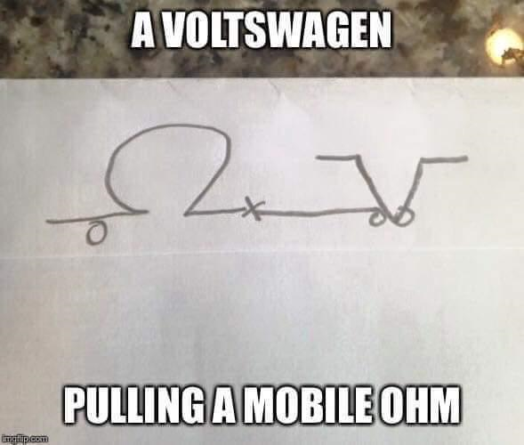
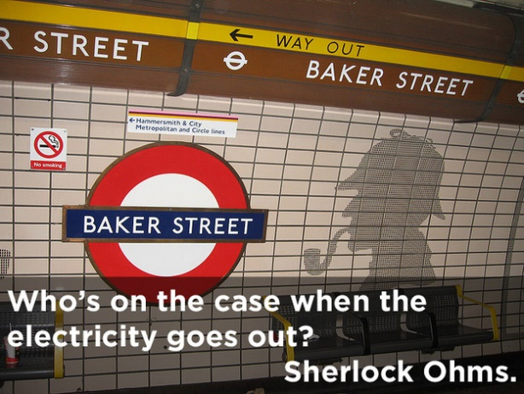
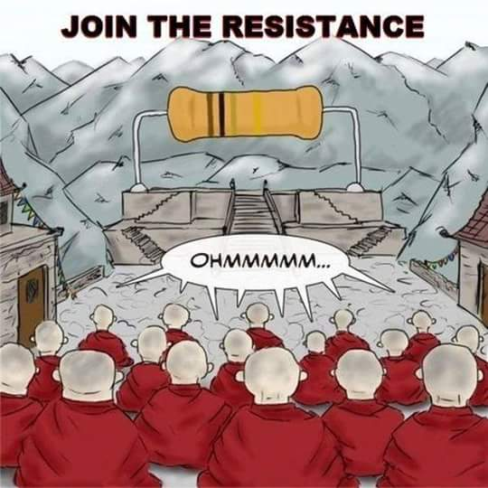

The potential divider circuit
The total potential difference is divided between the two resistors according to the ratio of their resistances.
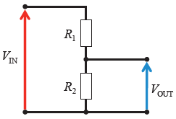
Look at the diagram on the right.
Let’s imagine that R₂ is four times greater than R₁
- This means that the potential difference across R₂ will be four times greater than the potential difference across R₁ (using V = IR for both, where the current (I) is the same for both resistors).
V₂ = 4 V₁

- The total potential difference across the resistors is the same as V_{IN}.

- Therefore in this scenario if V_{IN} was 30 volts then the voltage across R₁ would be 6 volts and the voltage across R₂ would be 24 volts.
- An interesting point to note is that it doesn’t matter what the value of the resistors are; it’s the ratio that’s important (‘interesting’ may be stretching things a little, but you know what I mean).

The potentiometer
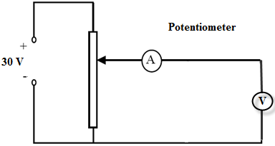
- In the diagram for the potential divider circuit at the top of the page, the voltage out (the voltage across R₂) is fixed and will only change if the temperature of R₂ or R₁ was to change.
A simple way to gradually vary the voltage out is to replace R₁ and R₂ by a single length of resistance wire and simply slide the contact up or down this wire as shown.
- The output voltage is then the voltage between the bottom line and the middle contact.

- A potentiometer is therefore a variable voltage divider with a slide control for setting the division ratio.

- If you replaced the voltmeter with a light-bulb you would notice the bulb getting brighter as you moved the contact upwards.

Why do we bother with this?

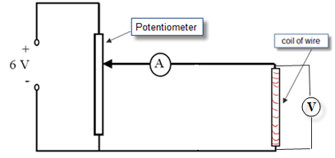
Because when you’re changing the voltage dial on a school power supply, in effect what you are doing is moving the position of the ‘slider’ above.

Can you now see how this works to vary the potential difference across the coil of wire in the following circuit (which is the circuit diagram for a number of the mandatory experiments in this chapter)?

The Wheatstone bridge

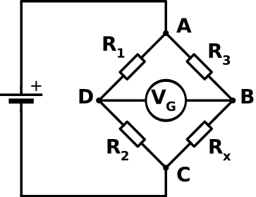
A Wheatstone bridge can be used to find the resistance of an unknown resistor.

It can be shown that when the Wheatstone bridge is balanced (see footnote below) the relationship between 4 resistors arranged as shown is
$$\frac{R_{1}}{R_{2}}=\frac{R_{3}}{R_{4}}$$

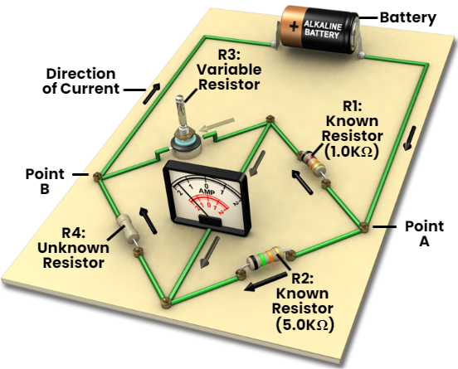
Therefore knowing the values of any three resistors allows us to calculate the fourth .

- When using this formula make sure that the resistors are arranged as shown with R₁ and R₂ on one arm and R₃ and R₄ on the other arm.
- Note that the supplied emf connects two points and the galvanometer connects the other two points.

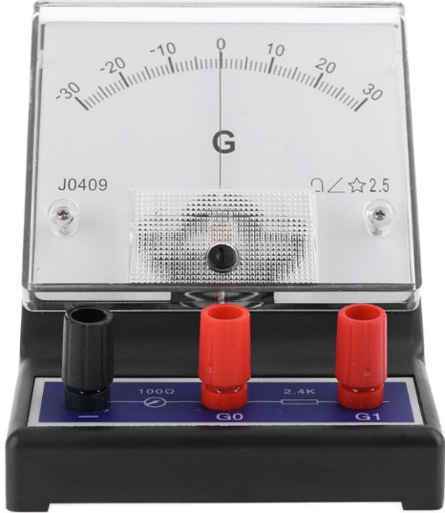

A galvanometer is a very sensitive analogue voltmeter. It doesn’t have any numbers on it; it simply registers whether or not there is any potential difference between two points. If a galvanometer is balanced there will be no deflection of the pointer. The galvanometer is used in the setup above to show that the bridge is balanced. resistor.

Uses of a Wheatstone Bridge
Remember that the bridge above was balanced to begin with, so no current flows through the galvanometer.
Now if the temperature of one of resistors is changed for any reason, current will flow through the galvanometer.
This current can be used to activate a second circuit such as a heater or an alarm.
Examples
- Temperature control (the resistance increases when it heats up).
- A stress-gauge (the resistance of the conductor in a strain gauge increases when a force is applied to it).

Wheatstone Bridge maths questions

2014 Question 10 [Higher Level]
- How would an observer know that a Wheatstone bridge is balanced?
- The Wheatstone bridge in the diagram is balanced. What is the resistance of the unknown resistor?

Part (i)
The galvanometer will have a zero reading on the galvanometer / there will be no deflection of / no current flowing through galvanometer
Part (ii)
The formula for a balanced Wheatstone bridge is as follows:
$\frac{R_{1}}{R_{2}}=\frac{R_{3}}{R_{4}}$ ⇒ $\frac{5.1}{R_{2}}=\frac{11.9}{40.5}$ ⇒ R₂ = $\frac{(5.1)(40.5)}{11.9}$ ⇒ R₂ = 17.36 Ω

2012 Question 9 [Higher Level]
A Wheatstone bridge circuit is used to measure the resistance of an unknown resistor R.
The bridge ABCD is balanced when
X = 2.2 kΩ, Y = 1.0 kΩ and Z = 440 Ω.

What is the resistance of the unknown resistor R?

Solution
It would have been really helpful here if the exam question had shown where which two points were connected by the galvanometer (in this case the galvanometer would connect the points A and C because we can see that the supply voltage connects the other two points).
Knowing this, we can say that resistors X and Y are on one line and resistors R and Z are on the second line.
X = 2200 Ω
Y = 1000 Ω
Z = 440 Ω

$\frac{R_{1}}{R_{2}}= \frac{R_{3}}{R_{4}}$ ⇒ $\frac{X}{Y}= \frac{R}{Z}$ ⇒ $\frac{2200}{1000}= \frac{R}{440}$ ⇒ $\frac{(2200)(440)}{1000}= R$ ⇒ R = 968 Ω

The metre bridge
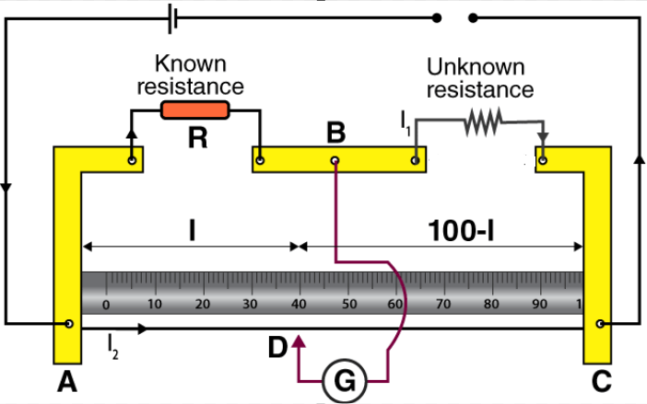

- This is similar in principle to the Wheatstone bridge except in this case two of the resistors are replaced by a single strip of uniform-resistance wire (in this case AC).
- The balance point can be reached by simply sliding the contact wire along this lower uniform-resistance wire (rather than swapping resistors in and out).
- One of the resistors is known and the two lengths can be measured.
- Resistance is proportional to length so instead of using R₃/R₄ we can use l₁/l₂.
- The unknown resistance can then be found using the following relationship:

Example: 2007 No. 9
A metre bridge was used to measure the resistance of a sample of nichrome wire.
The diagram above indicates the readings taken when the metre bridge was balanced.
Calculate the resistance of the nichrome wire

Solution
R₁ = 7.86 Ω


http://xkcd.com/356/

TO INVESTIGATE THE VARIATION OF CURRENT WITH POTENTIAL DIFFERENCE FOR A FILAMENT BULB

APPARATUS
Low voltage variable power supply, voltmeter, ammeter, filament bulb.
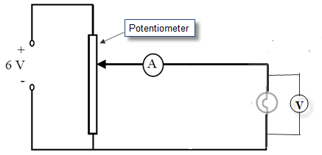

DIAGRAM

PROCEDURE
- Set up the circuit as shown (replace the letter X with A for ammeter above, and don’t write this into your report).
- Record the potential difference (V) and the current (I) using the voltmeter and ammeter respectively.
- Adjust the potential divider to obtain different values for V and I.
- Obtain at least six values for V and I.
- Plot a graph of I against V.

RESULTS

V (V)
I (A)

CONCLUSION
- As the potential difference across the bulb increases so does the current, but not in a linear fashion therefore the two are not directly proportional.
- We believe our results to be reliable because they resulted in a smooth curve, as the theory predicted.

Graph of current against potential difference for a filament light bulb


Exam questions
HL: 2017, 2015, 2005 OL: 2011, 2003

- [2011 OL]
The diagram shows a circuit used to investigate the variation of current with potential difference for a filament lamp.

- Name the instrument X. What does it measure?
- Name the component Y. What does it do?

The table shows the values recorded for the current and the potential difference during the investigation.

Potential difference/ V | 1 | 2 | 3 | 4 | 5 | 6 | 7
Current/A | 0.9 | 1.6 | 2.1 | 2.5 | 2.8 | 3.0 | 3.1

- Draw a graph, on graph paper, of the current against the potential difference.
- What does your graph tell you about the variation of current with potential difference for a filament lamp?
- Using your graph, calculate the resistance of the lamp when the potential difference across the lamp is 5.5 V.

- [2003 OL]
The diagram shows the circuit used by a student to investigate the variation of current with potential difference for a filament bulb.
- Name the apparatus X. What does it measure?
- Name the apparatus Y. What does it do?
The table shows the values obtained for the current and the potential difference during the experiment.
Potential difference /V | 2.0 | 3.0 | 4.0 | 5.0 | 6.0 | 7.0 | 8.0 | 9.0
Current /A | 1.0 | 1.5 | 1.9 | 2.3 | 2.6 | 2.9 | 3.2 | 3.5

- Draw a graph, on graph paper, of the current against the potential difference.
- Use your graph to find the resistance of the bulb when the current is 3 A.
- The resistance of the bulb is 2.0 Ω when the current is 1.5 A. Explain why the resistance of the bulb when the current is 1.5 A is different from its resistance when the current is 3 A.

- [2005]
A student investigated the variation of the current I flowing through a filament bulb for a range of different values of potential difference V.
- Draw a suitable circuit diagram used by the student.
- Describe how the student varied the potential difference.
- The student drew a graph, as shown, using data recorded in the experiment.
With reference to the graph, explain why the current is not proportional to the potential difference.
- With reference to the graph, calculate the change in resistance of the filament bulb as the potential difference increases from 1 V to 5 V.
- Give a reason why the resistance of the filament bulb changes.
Solutions

[2011 OL]

- Voltmeter - measures voltage
- Rheostat / (variable) resistor / potential divider / potentiometer
Changes resistance / voltage / current
- See graph
- The relationship between current and potential difference for a filament lamp is non linear / not proportional
- R = 5.5 ÷ 2.9 = 1.9 ± 0.2 Ω

[2003 OL]

- X is an ammeter. It measures current.
- Y is a voltmeter. It measures volts.
- See graph
- When the current is 3 A the voltage is 7.2 V, so using V = IR results in R = 2.4 Ω.
- Because the resistance of the bulb increases with temperature, and temperature is greater when the current is greater.

[2005 HL]

- See diagram
- By adjusting the voltage on the power supply.
- Because the graph is not a straight line.
- At 1 V: R = V/I = 1/0.028 = 35.7 Ω
At 5 V: R = (5/0.091) = 54.9 Ω
Change in resistance (= 54.9 – 35.7) = 19.2 Ω
- As current increases the temperature of filament increases, therefore the filament gets hotter and it gets more difficult for electrons to pass through due to increased vibration of the metal atoms.

TO INVESTIGATE THE VARIATION OF CURRENT WITH POTENTIAL DIFFERENCE FOR A METALLIC CONDUCTOR

APPARATUS
Low voltage variable power supply, voltmeter, ammeter, length of nichrome wire.

DIAGRAM

PROCEDURE
- Set up the circuit as shown.
- Record the potential difference (V) and the current (I) using the voltmeter and ammeter respectively.
- Adjust the potential divider to obtain different values for V and I.
- Obtain at least six values for V and I.
- Plot a graph of I against V.
- Calculate the slope of the graph.
If plotting V on the y-axis and I on the x-axis then the slope of the graph corresponds to the resistance of the metallic conductor.
If plotting V on the x-axis and I on the y-axis then the slope of the graph corresponds to the inverse of the resistance of the metallic conductor.

RESULTS
V (V)
I (A)

CONCLUSION
- Our graph resulted in a straight line through the origin which implies that the current is directly proportional to the potential difference.
- We believe our results to be reliable because they resulted in a straight line through the origin, as the theory predicted.
- The resistance of the wire may be determined from the reciprocal of the slope of the graph.

PRECAUTIONS
- Use a low voltage so that the current flowing will be small enough that the temperature of the wire stays constant.
- Use a sensitive milli-ammeter and voltmeter to get accurate readings.

NOTES
A varying voltage can be obtained from a fixed supply voltage by using a potential divider. It consists of a variable resistor or fixed resistors in series. Move the slider to change the output voltage. This results in the output voltage from the potential divider being a fraction of the input voltage.

Normally we would put voltage on the vertical axis and current on the horizontal-axis, and therefore the slope of the graph would correspond to the resistance. In this case however calculating the resistance is not the main focus of the experiment; the aim is to investigate how the current depends upon the potential difference. That is why we put the independent variable (the one we have control over) on the X-axis. Hence current goes on the Y-axis.
We use the same approach for all of the variations (filament bulb, copper sulphate, semi-conductor diode).

For the coil of wire you could use a separate rheostat. The two connections in this are both at the bottom.
Alternatively, you could use 1 m of 26 s.w.g. nichrome wire wound on a plastic comb. This has a resistance of approximately 7.0 Ω. Third option is filament in a calorimeter (make sure to have it immersed in water).
Graph of current against potential difference for a metallic conductor

TO MEASURE THE RESISTIVITY OF THE MATERIAL OF A WIRE
APPARATUS
Length of nichrome wire, micrometer or digital calilpers, ohmmeter, metre stick.

DIAGRAM

PROCEDURE

- Tie a length of nichrome between the bars of the two stands as shown above. Stretch the wire enough to remove any kinks or ‘slack’ in the wire.

- Note the resistance of the leads when the crocodile clips are connected together.

- Connect the crocodile clips to the wire. Read the resistance from the ohmmeter. Subtract the resistance of the leads to get the resistance R of the wire.

- Measure the length (L) of the wire between the crocodile clips with the metre stick.

- Find the diameter (d) of the wire at different points, taking the zero error into account. Find the average value of the diameter d. We use a digital callipers instead of the micrometer.
- Calculate the resistivity using the formula $ρ=\frac{RA}{L}$ where A represents the cross-sectional area of the wire, which is circular in shape.
Therefore A = π$r^{2}$
- Repeat using different lengths of wire and calculate an average value for ρ.
RESULTS

Resistance (Ω m) | L (m) | Diameter d (m) | A= $πr^{2}$ | $ρ=\frac{RA}{L}$ (Ω m)

Average value for resistivity = ________________ Ω m.

SOURCES OF ERROR / PRECAUTIONS
- Ensure that the wire is straight when measuring its length.
- Measure only between the inside of the ohmmeter contacts.
- Make sure to zero the reading on the callipers before starting.

NOTE
When setting up lay the wire over a metre stick and clamp it to using G-clamps. The length of wire can now be measured directly.

Theory questions

Describe how the student measured the resistance of the wire. | By using an ohmmeter/ by using a multimeter set to read resistance
Name an instrument to measure the diameter of the wire and describe how it is used. | A digital calipers.
Describe the steps involved in finding the average diameter of the wire. | Close the jaws and zero the reading on the calipers.  Tighten the jaws around the wire and note the reading.  Repeat at different points and get an average.
How did the student ensure that the wire was of uniform diameter? | Measure diameter/thickness at different positions // no kinks
Why did the student measure the diameter of the wire at different places? | It may not have been of uniform diameter.
Describe the procedure used in measuring the length of the sample of wire. | Stretch the wire out along a metre stick and clamp it at both ends so that there are no kinks.  Measure the length between the multimeter contact points.
Give one precaution that the student took when measuring the length of the wire. | She made sure that there were no kinks.
State two precautions which should be taken in order to obtain an accurate result. | Make sure there are no kinks, avoid parallax error when measuring the length.
The experiment was repeated on a warmer day. What effect did this have on the measurements? | Resistance, length and diameter would all have increased.

Exam questions
HL: 2016, 2009, 2004 OL: 2015, 2010, 2005

- [2010 OL]
R/Ω | 20.2
l/cm | 48.8
d/mm | 0.21 | 0.20 | 0.18
In an experiment to determine the resistivity of the material of a wire, a student measured the length, diameter and resistance of a sample of nichrome wire.
The table shows the data recorded by the student.

- Describe how the student measured the resistance of the wire.
- Describe how the length of the wire was measured.
- What instrument did the student use to measure the diameter of the wire?
- Why did the student measure the diameter of the wire at different places?
- Using the data, calculate the cross-sectional area of the wire.
- Find the resistivity of nichrome.

- [2009]
In an experiment to measure the resistivity of nichrome, the resistance, the diameter and appropriate length of a sample of nichrome wire were measured.
The following data were recorded:
Resistance of wire = 7.9 Ω
Length of wire = 54.6 cm
Average diameter of wire = 0.31 mm
- Describe the procedure used in measuring the length of the sample of wire.
- Describe the steps involved in finding the average diameter of the wire.
- Use the data to calculate the resistivity of nichrome.
- The experiment was repeated on a warmer day. What effect did this have on the measurements?

- [2004]
The following is part of a student’s report of an experiment to measure the resistivity of nichrome wire.
“The resistance and length of the nichrome wire were found. The diameter of the wire was then measured at several points along its length.”
The following data was recorded.
Resistance of wire = 32.1 Ω
Length of wire = 90.1 cm
Diameter of wire = 0.19 mm, 0.21 mm, 0.20 mm, 0.21 mm, 0.20 mm
- Name an instrument to measure the diameter of the wire and describe how it is used.
- Why was the diameter of the wire measured at several points along its length?
- Using the data, calculate a value for the resistivity of nichrome.
- Give two precautions that should be taken when measuring the length of the wire.

Worked solutions

[2010 OL] | - Average diameter = 0.197 mm ⇒ r = 0.0001m  - cross-sectional area  A = π(0.1 × 10⁻³)²  A = 3.03 × 10⁻⁸ – 3.14 × 10⁻⁸ m²  - Find the resistivity of nichrome.  $ρ=\frac{RA}{l}$  Ƿ = (20.2)(3.14 × 10⁻⁸)/(0.488)  Ƿ = 1.25 – 1.29 × 10⁻⁶ Ω m)
  R/Ω | 20.2
  l/cm | 48.8
  d/mm | 0.21 | 0.20 | 0.18
[2009 HL]  Resistance of wire = 7.9 Ω  Length of wire = 54.6 cm  Average diameter of wire = 0.31 mm | A = πr²  ⇒ A = π(0.155 × 10⁻³)²  = 7.55 × 10⁻⁸ m²  $ρ=\frac{RA}{l}$  ⇒ $ρ=\frac{\left(7.9\right)\left(7.55×{10}^{-8}\right)}{0.546}$  ⇒ ρ = 1.09 × 10⁻⁶ Ωm
[2004 HL]  Resistance of wire = 32.1 Ω  Length of wire = 90.1 cm  Diameter of wire = 0.19 mm, 0.21 mm, 0.20 mm, 0.21 mm, 0.20 mm | Average diameter = 0.202 mm  A = πr ² = 3.2 ×10⁻⁸ m²  $ρ=\frac{RA}{l}$  ⇒ $ρ=\frac{\left(32.1\right)\left(3.2×{10}^{-8}\right)}{0.901}$  $ρ = \frac{RA}{l}$$ρ= \frac{\left(32.1\right)(3.2×{10}^{-8) }}{0.901}$⇒ ρ = 1.1×10⁻⁶ Ω m

TO INVESTIGATE THE VARIATION OF RESISTANCE OF A METALLIC CONDUCTOR WITH TEMPERATURE

APPARATUS
Coil of wire, glycerol, beaker, heat source, thermometer, ohmmeter, boiling tube

DIAGRAM

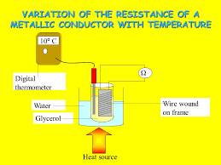

PROCEDURE
- Set up the apparatus as shown in the diagram.

- Use the thermometer to note the temperature of the glycerol, which we assume to be the same as the temperature of the coil.

- Record the resistance of the coil of wire using the ohmmeter.

- Heat the beaker and for each 10 °C rise in temperature record the resistance and temperature using the ohmmeter and the thermometer.

- Plot a graph of resistance against temperature.

R (Ω)
θ (⁰C)
RESULTS

CONCLUSION
From the graph we can see that there is a linear relationship between the temperature of the wire and its resistance, and that as one increases so does the other.

PRECAUTIONS / SOURCES OF ERROR
- Check for the resistance of the connecting leads and contacts on the ohmmeter. Subtract from later readings
- Heat very slowly to try to maintain thermal equilibrium between the water and glycerol and coil. When the bunsen is removed wait until the temperature is steady before taking the resistance readings.
- Use glycerol in the test tube as it is a better heat conductor than water. If water is used it forms bubbles around the thermistor and is therefore not a good thermal contact (glycerol does not do this) and glycerol has a low heat capacity.

Graph of resistance against temperature for a metallic conductor

Exam questions
OL: 2006 HL: 2015, 2008

- [2006 OL]
Temperature / ºC | 20 | 30 | 40 | 50 | 60 | 70 | 80
Resistance / Ω | 45.6 | 49.2 | 52.8 | 57.6 | 60.0 | 63.6 | 68.4
In an experiment to investigate the variation of resistance with temperature for a metallic conductor in the form of a wire, a student measured the resistance of the conductor at different temperatures. The table shows the measurements recorded by the student.
- How did the student measure the resistance of the wire?
- Describe, with the aid of a diagram, how the student varied the temperature of the wire.
- Using the data in the table, draw a graph on graph paper of the resistance of the conductor against its temperature. Put temperature on the horizontal axis (X-axis).
- Use the graph to estimate the temperature of the conductor when its resistance is 50 Ω.
- What does your graph tell you about the relationship between the resistance of a metallic conductor and its temperature?

- [2015]
In an experiment to measure the variation of the resistance R of a metallic conductor with its temperature θ, a student recorded the following data.
θ (ºC) | 15 | 20 | 30 | 40 | 50 | 60 | 80 | 100
R (Ω) | 6.0 | 6.2 | 6.5 | 6.8 | 7.2 | 7.5 | 8.2 | 8.8

- Using the recorded data, plot a graph to show the variation of the resistance of the metallic conductor with its temperature.
- Use your graph to estimate the rate of change of resistance with respect to temperature for the metallic conductor
- Use your graph to estimate the resistance of the metallic conductor when it is immersed in melting ice.

- [2008]
A student investigated the variation of the resistance R of a metallic conductor with its temperature θ.
θ/ºC | 20 | 30 | 40 | 50 | 60 | 70 | 80
R/Ω | 4.6 | 4.9 | 5.1 | 5.4 | 5.6 | 5.9 | 6.1
The student recorded the following data.
- Describe, with the aid of a labelled diagram, how the data was obtained.
- Draw a suitable graph to show the relationship between the resistance of the metal conductor and its temperature.
- Use your graph to estimate the resistance of the metal conductor at a temperature of –20 ºC.
- Use your graph to estimate the change in resistance for a temperature increase of 80 ºC.
- Use your graph to explain why the relationship between the resistance of a metallic conductor and its temperature is linear.

Worked solutions

[2006 OL]
- How did the student measure the resistance of the wire?
By using a multimeter set to measure resistance.
- Describe, with the aid of a diagram, how the student varied the temperature of the wire.
See diagram.
The temperature was varied by allowing the wire to be heated.
- Draw a graph on graph paper of the resistance of the conductor against its temperature.
See graph
- Use the graph to estimate the temperature of the conductor when its resistance is 50 Ω.
32 ⁰C
- What does your graph tell you about the relationship between the resistance of a metallic conductor and its temperature?
There is a linear relationship (as temperature increases, so does resistance). Note that they are not proportional / directly proportional.

[2015]
- Using the recorded data, plot a graph to show the variation of the resistance of the metallic conductor with its temperature.
Correctly labelled axes
7 points correctly plotted
Straight line with good fit
- Use your graph to estimate the rate of change of resistance with respect to temperature for the metallic conductor
Correct rate/slope from graph ≈ 0.033 $Ω$ K⁻¹
- Use your graph to estimate the resistance of the metallic conductor when it is immersed in melting ice.
correct intercept / Correct use of rate/slope
R ≈ 5.5 Ω
[2008]
- Describe, with the aid of a labelled diagram, how the data was obtained.
The resistance was read from the ohmmeter, the temperature was read from the thermometer and the readings were varied using the heat source.
- Draw a suitable graph to show the relationship between the resistance of the metal conductor and its temperature.
See graph
- Use your graph to estimate the resistance of the metal conductor at a temperature of –20 ºC.
Continue (extrapolate) the graph on the left hand side and then read off the resistance value that corresponds to the temperature of – 20 ⁰C.
R = 3.6 Ω
- Use your graph to estimate the change in resistance for a temperature increase of 80 ºC.
6.2 Ω (at 80 ºC) and 4.2 Ω (at 0 ºC)  change in resistance ≈ 2 Ω
- Use your graph to explain why the relationship between the resistance of a metallic conductor and its temperature is linear. (This was mistakenly termed ‘non-linear’ in the original exam paper).
A straight line is obtained.

SLOP

Define resistance | The resistance of a conductor is the ratio of the potential difference across it to the current flowing through it.
State Ohm’s Law | Ohm’s Law states that the current flowing through a conductor is directly proportional to the potential difference across it, assuming constant temperature.
Draw the symbol for a variable resistor
Define resistivity. | The resistivity of a material is defined as the resistance of a cube of material of side 1 metre.
Give the unit of resistivity. | The unit of resistivity is the ohm metre (Ω m).
A toaster has a heating coil made of nichrome which it has a resistance of 12 Ω.  The coil is 40 m long and it has a circular cross-section of diameter 2.2 mm.  Calculate the resistivity of nichrome. | ⇒ ρ = 12 × π (1.1 × 10⁻³)² / 40  = 1.14 × 10⁻⁶ Ω m.
The total length of the cables connecting the industrial park to the power station is 15 km.  The cables have a diameter of 10 mm and are made from a material of resistivity 5.0 × 10⁻⁸ Ω m.  Calculate the total resistance of the cables. | A = πr² = π(.005)²  ρ = RA/l  ⇒ R = ρl/A  ⇒ R = (5.0 × 10⁻⁸)(15000)/ π(.005)² ⇒ R = 9.6 Ω
Explain why the resistance of the bulb is different when it is not connected to the mains. | When it is not connected to the mains it is not as how and therefore it will have a lower resistance.
Draw a sketch of the graph to show the relationship between resistance and temperature. | Temperature on the horizontal axis. Straight line going through a point on the vertical (resistance) axis.
Describe the relationship between resistance and temperature for a metallic conductor. | There is a linear relationship between them (they are NOT proportional).
Draw a labelled diagram of the arrangement of the apparatus | See notes

4. Effects of an electric current and domestic circuits

Student notes

There are three effects of an electric current; a magnetic effect, a chemical effect and a heating effect

The magnetic effect of an electric current
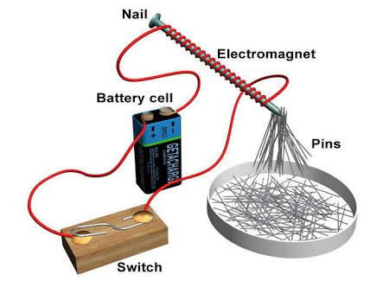

The chemical effect of an electric current
Example: hydrolysis (using an electrical current to split water into hydrogen and oxygen).
You must know the meaning of each of the following as they relate to the diagram.
- Electrolyte (the solution)
- Electrodes (the metal contacts)
- Anode (electrode connected to the positive terminal)
- Cathode (electrode connected to the negative terminal)
- Inactive electrodes do not take part in the reaction (e.g. platinum in water)
- Active electrodes take part in the chemical reaction (one terminal gets lighter while the other gets heavier e.g. copper electrodes in a solution of copper sulphate)

Applications of the chemical effect of a current
- Electroplating
- Extracting metals from their ores

The heating effect of an electric current
Remember that any time work is done energy is being converted from one form to another.
In this section the work done corresponds to the conversion of electrical energy to heat energy.
The question below acts as a suitable introduction:

2008 Question 7 [Higher Level]  A toaster has a power rating of 1050 W when it is connected to the mains supply.  Calculate the heat generated by the toaster in 2 minutes if it has an efficiency of 96%. | Solution  P = 1050 W, t = 2 minutes = 120 seconds  $power=\frac{work}{time}$ work = power × time  Heat generated = energy = work = power × time = (1050)(120) = 1.26 × 10⁵ J  96% of 1.26 × 10⁵ = 1.21 × 10⁵ J

Relationship between work, current, resistance and time
We now look at the factors that affect the rate at which electrical energy is converted to heat energy.
W = I²Rt
The following relationship was discovered experimentally by James Joule:

But $power=\frac{work}{time}$ so power = I²R This is Joule’s Law

Joule’s Law
P = I²R

Joule’s Law states that the rate at which heat is produced in a conductor is proportional to the square of the current, provided the resistant is constant.

Joules’ law exam questions
2013 Question 8 (b) [Higher Level]  A 3 km length of aluminium wire which has a resistance 0.33 Ω is used to carry a current of 250 A.  Calculate how much electrical energy is converted to heat energy in the wire in ten minutes. | Solution  R =0.33 Ω, I = 250 A,  t = 10 ten minutes = 600 seconds  W = I²Rt ⇒  W = (250)²(0.33)(600) = 1.238 × 10⁷ J
2011 Question 12 (c) [Higher Level]  An electric cable consists of a single strand of insulated copper wire.  The wire is of uniform cross-sectional area and is designed to carry a current of 20 A.  To preserve the insulation, the maximum rate at which heat may be produced in the wire is 2.7 W per metre length.  Calculate the maximum resistance per metre of the wire | Solution  For each metre:  I = 20 A, P = 2.7 W, ${P=RI}^{2}$ ⇒ ${2.7=R(20)}^{2}$  R = $\frac{2.7}{400}=$6.75 × 10⁻³ Ω

Why is electrical energy transmitted using high voltage power lines?

We have seen that the heat produced by an electric current is given by the formula P = I²R.
This means that a large current will produce a lot of heat energy. This is a waste of energy and therefore should be minimised if possible. However we also know that P = VI, which means that if we double the voltage we halve the current while still keeping the power constant. In practice we make the current very small by making the voltage very large (e.g. 300 kV) when electrical energy is being carried across the countryside.
Transformers are used to change the voltage up or down

2002 Question 8 [Higher Level]

The ESB supplies electrical energy at a rate of 2 MW to an industrial park from a local power station, whose output voltage is 10 kV. The total resistance of the cables is 9.6 Ω.
- Calculate the current flowing in the cables.
- Calculate the rate at which energy is “lost” in the cables.
- Suggest a method of reducing the energy “lost” in the cables.
Solution
Part (i)
P = 2 MW = 2 ×10⁶ W
V = 10 kV = 10000 V
P = VI ⇒ $I=\frac{P}{V}$ $I=\frac{2 × {10}^{6} }{10000}$ = 200 A
Part (ii)
Note that in this context P corresponds to the rate at which electrical energy is converted to heat energy (and not the power rating of the electrical generating station).
Similarly if there was a reference to voltage or potential difference in this context it would correspond to the potential difference drop across the cable and not the supply voltage.
I = 200 A, R = 9.6 Ω, P = I²R ⇒ P = (200)²(9.6) = 3.8 × 10⁵ W

Part (iii)
If the electrical energy was transferred at a higher voltage it would result in a lower current therefore less energy lost as heat.
Alternatively you could use thicker cables which would result in lower resistance therefore less heat loss (although this would be more expensive).

"Nothing can be more fatal to progress than a too confident reliance on mathematical symbols; for the student is only too apt to take the easier course and consider the formula not the fact as the physical reality." Lord Kelvin

Domestic electric circuits

3-Pin plug with fuse Miniature Circuit Breakers (MCB) Residual Current Devices (RCD)

Plugs | Brown – Live wire (think BRown is Bottom Right)  Blue – Neutral wire (think BLue is Bottom Left)  Green/Yellow – Earth wire (think Top is third wire)  Current comes in on the live and has to pass through the fuse before getting to the appliance.
Fuses | 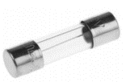  Melts if too large a current flows through it.  The fuse is always on the live wire
Earthing and bonding | All metal taps are connected to wires which in turn are connected to earth.  This prevents electrocution if the tap was to become accidentally ‘live’ (or maybe because the plumber was a bit of a cowboy).  Electrical bonding involves electrically connecting all exposed metal items not designed to carry electricity in a room or building (like copper water pipes) as protection from electric shock.
MCBs | Miniature Circuit Breakers have the advantage that they do not need to be replaced when they trip.  They can contain an electromagnet and/or a bimetallic strip.  Either way, when the current exceeds a preset value, the circuit should break.
RCDs | Residual Current Devices operate by detecting a difference between the current on the live wire and the current on the neutral wire.  These should be the same, but if they are not this indicates a problem, and so the RCD trips.  Note that RCBs act quicker and are therefore safer than MCBs.
Ring Circuits | In a ring circuit the live wire from each of the sockets are connected to a common line, as is the case with the neutral wire from each socket (on that particular ring).
Radial Circuits | Appliances that take a large current have their own live wire going in, and neutral wire coming out of, the appliance (from the fuse box).  Examples would include a cooker or a washing machine.

Related mathematical exam questions

2017 Question11 [Ordinary Level]  What is the maximum power that an appliance with a 13 A plug can use when connected to a 220 V supply? | Solution  V = 220 V, I = 13 A  P = VI = 220 × 13 = 2860 W
2011 Question 12 (c) [Ordinary Level]  An electric screwdriver has a power rating of 120 W when connected to its 24 V battery.  Calculate the current supplied by the battery when the screwdriver is turned on. | Solution  P = 120 W, V = 24V  P = VI  120= 24 × I I = 5 A
2003 Question 8 [Ordinary Level]  The fuse in the plug of an electric kettle was replaced with a 5 A fuse. The kettle has a power rating of 2 kW when connected to the ESB mains voltage of 230 V.  - Calculate the current that flows when the kettle is first plugged in.  - This current will only flow for a very short time. Explain why. | Solution  Part (i)  P = 2000 W, V = 230 V,  P = VI I = P/V I = 2000/230 I = 8.7 A  Part (ii)  The current of 8.7 A is greater than the fuse rating of 5 A so the fuse will quickly melt, breaking the circuit.
2020 Question 5 [Higher Level]  An electric heater has a power rating of 1500 W.  It uses a voltage of 230 V. Which fuse should be used in the plug, a 3 A fuse or a 13 A fuse?  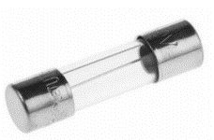  Justify your answer. | P = 1500 W, V = 230 V,  P = VI I = P/V I = 1500/230 I = 6.5 A.  This is the expected current so if a 3 A fuse was used it would quickly blow therefore a 13 A fuse should be used.
2019 HL Question 5  Power P is generated in a resistor of resistance R when a potential difference V is applied across it.  Write P in terms of R and V. | Solution  P = VI (now use I = V/R)  P = V²/R
2010 Question 8 [Higher Level]  A hair dryer with a plastic casing uses a coiled wire as a heat source.  The maximum power generated in the heating coil is 2 kW.  - Calculate the current that flows through the coil when the dryer is turned on.  - What is the initial resistance of the coil?  - Explain why the current through the coil would decrease if the fan developed a fault and stopped working. | Solution  Part (i)  P = 2000 W V = 230 V  P = VI⇒ I = $\frac{P}{V}$ = $\frac{2000}{230}$  I = 8.7 A  Part (ii) V = RI ⇒ R = $\frac{V}{I}= \frac{230}{8.7}$ R = 26.4 Ω  Part (iii) If the fan stopped working it would mean that the coil gets hotter therefore its resistance increases so current would decrease.

The kilowatt-hour
The kilowatt hour is used as a billing unit for energy delivered to consumers by electric utilities.

One kilowatt hour is the amount of energy used by a 1000 watt appliance in one hour.
Number of kilowatt-hours = number of kilowatts × number of hours

2004 Question 9 [Ordinary Level]  Calculate the cost of using a 2 kW electric heater for 3 hours at 10 cent per kilowatt-hour. | Solution  No. of kW = 2  No. of hours = 3  No. of kWhours = no. of kilowatts × no. of hours  = (2 × 3) = 6 kW hours  Cost = 6 × 10 = 60 cent
2012 Question 8 [Ordinary Level]  A plug is used to connect an electrical appliance in the home to the 230 volt mains supply.  Modern plugs contain a small fuse which comes with a rating of 1A, 2A, 3A, 5A or 13A.  A vacuum cleaner has a power rating of 900 W.  - What is the most suitable fuse to use in the plug of the vacuum cleaner?  - If the vacuum cleaner is used for 90 minutes, calculate the number of units of electricity used.  - Calculate the cost of the energy used if the price of each unit of electricity is 22 cent. | Part (i)  P == 900 W, V = 230 V, P = VI  I = P/V = 900/230 = 3.9 A  The most suitable fuse is the one with a current rating just above 3.9 amps so a 5 amp fuse should be used.  Part (ii)  P = 900 W = 0.9 kW t = 90 minutes = 1.5 hours  No. of kWhours = no. of kilowatts × no. of hours  = (0.9 × 1.5) = 1.35 kW hours  Part (iii)  Cost = (1.35)(22) = 29.7 cent / 30 cent
2009 Question 8 [Ordinary Level]  Plugs are used to connect electrical appliances in the home to the 230 volt ESB supply. Modern plugs contain a small fuse which comes with a rating of 1A, 2A, 3A, 5A or 13A.  - A coffee maker has a power rating of 800 W.  What is the most suitable fuse to use in the plug of the coffee maker?  - If the coffee maker was in use for 150 minutes:  Calculate the number of units of electricity used by the coffee maker.  - Calculate the cost of the electricity used if each unit costs 15 cent. | Part (i)  P = 800 W, V = 230 V  P = VI I = P/V = 800/230 = 3.4 A  So the most suitable fuse is the 5 A fuse.  Part (ii)  P = 800 W = 0.8 kW t = 150 mins = 2.5 hours  No. of kWhours = no. of kilowatts × no. of hours  = 0.8 × 2.5  = 2 kW hours  Part (iii)  Cost = 2 × 15 = 30 cent

Relationship between current and voltage for different conductors

You must be able to draw a graph for each of the following, list the charge carriers in each case, and explain the shape of each graph.
Note that in this case we are not looking to obtain a value for the slope of the graph, and therefore we put the independent variable (Voltage) on the X-axis.

Conductor | Graph | Charge  Carriers | Explanation
A Metallic conductor |  | Electrons | As the p.d. is increased, the current  increases proportionally.
A Filament Bulb |  | Electrons | As current increases, the wire heats up,  ⇒resistance increases,  ⇒current does not rise as rapidly.
Ionic solutions  (active electrodes) |  | Positive and negative ions,  electrons | Copper ions discharged at the cathode are replaced by copper atoms entering the solution as ions in the anode.
Ionic solutions  (inactive electrodes) | 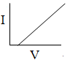 | Positive ions,  electrons | Oxygen is produced at the anode. This combines with the platinum to become a ‘cell’ which opposes the driving current and has to be overcome.
Vacuum | 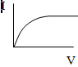 | electrons | Stage one – thermionic emission  Stage two - saturation
Gases | 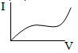 | Positive ions,  electrons | Stage one – Normal  Stage two – Saturation  Stage Three – Avalanche Effect
Semiconductors |  | Positive holes,  negative electrons | See Semiconductors topic for a detailed explanation

Electricity and death
The hazards of electricity (see table below) depend on the amount of electrical current, its frequency, its duration, its path through the body, and the physical condition of the person.
The resistance of the body varies from about 300 ohms to about 100,000 ohms, and thus even very low voltages can produce lethal shocks.
Fatalities have occurred at voltages as low as 24 volts.
Then the person is either thrown clear of the circuit or the current continues to rise until ventricular fibrillation or cardiac arrest occurs (at 50-200 mA), assuming the path of the current is through the heart.
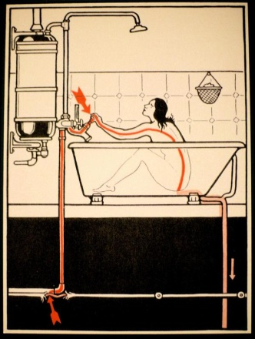
The probability of resuscitating someone is good if CPR is begun within three minutes but becomes poor after about six minutes.
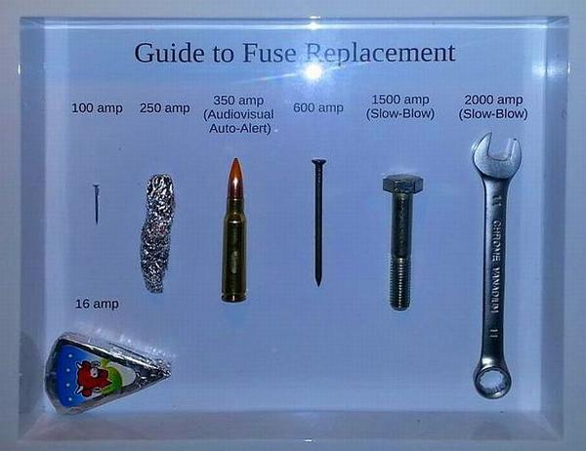
A ring circuit in a house
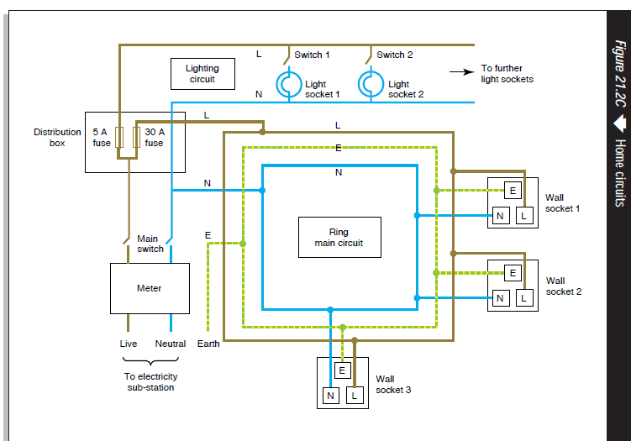

TO INVESTIGATE THE VARIATION OF POTENTIAL DIFFERENCE WITH CURRENT FOR COPPER ELECTRODES IN A COPPER-SULPHATE SOLUTION
APPARATUS:
Low voltage variable power supply, voltmeter, ammeter, copper electrodes in a copper-sulphate solution.
DIAGRAM:

PROCEDURE:
- Set up the circuit as shown.

- Record the potential difference (V) and the current (I) using the voltmeter and ammeter respectively.

- Adjust the rheostat to obtain different values for V and I.

- Obtain at least six values for V and I.

- Plot a graph of potential difference (V) against current (I) – see graph paper next page.

RESULTS:

V (V)
I (A)

CONCLUSION
- We obtained a straight line through the origin therefore the current through the copper-sulphate solution is proportional to the potential difference across it.
- We believe our results to be reliable because they resulted in a straight line through the origin, as the theory predicted.

SOURCES OF ERROR
- The copper-sulphate solution may not be concentrated enough.
- The copper electrodes may have become oxidised and will no longer conduct.

PRECAUTIONS
Sand the electrodes beforehand.

Graph of potential difference (V) against current (I)

Exam questions
HL: 2011, 2002 OL: 2012, 2004

[2004 OL]
The diagram shows a circuit used to investigate the variation of current with potential difference for a copper sulfate solution.
- Name the instrument used to measure the current.
- How was the potential difference measured in the experiment?
- Name the apparatus Y and give its function in the experiment.
V/V | 0 | 0.5 | 1.0 | 1.5 | 2.0 | 2.5 | 3.0
I/A | 0 | 0.3 | 0.6 | 0.9 | 1.2 | 1.5 | 1.8

The following table shows the values recorded for the current and the potential difference during the experiment
- Using the data in the table, draw a graph on graph paper of the current against the potential difference. Put current on the horizontal axis.
- Calculate the slope of your graph and hence determine the resistance of the copper sulphate solution.
[2011 HL]
A student investigated the variation of the current I through an electrolyte as the potential difference V across the electrolyte was changed. The electrolyte used was a solution of copper sulfate.
V/V | 0 | 1 | 2 | 3 | 4 | 5 | 6
I/mA | 0 | 30 | 64 | 93 | 122 | 160 | 195
The electrodes used were made of copper.
The student recorded the following data:

- Draw a suitable circuit diagram for this investigation and label the components.
- How was the potential difference changed during the investigation?
- Draw a suitable graph to show the relationship between the current and the potential difference in this investigation.
- Use your graph to calculate the resistance of the electrolyte.
- What was observed at the electrodes as current flowed through the electrolyte?
[2002 HL]
In an experiment to investigate the variation of current I with potential difference V for a copper sulfate solution, the following results were obtained.
V /V | 0.5 | 1.0 | 1.5 | 2.0 | 2.5 | 3.0 | 3.5 | 4.0 | 4.5 | 5.0
I /mA | 24 | 48 | 79 | 102 | 120 | 143 | 185 | 195 | 215 | 263
- Draw a diagram of the apparatus used in this experiment, identifying the anode and the cathode.
- Draw a suitable graph on graph paper to show how the current varies with the potential difference.
- Using your graph, calculate the resistance of the copper sulfate solution. (Assume the resistance of the electrodes is negligible.)
- Draw a sketch of the graph that would be obtained if inactive electrodes were used in this experiment.

Question: What should you do if your young son develops a nasty habit of eating electrical cable?
Answer: Ground him until he conducts himself properly.

Worked solutions

[2004 OL]
- Name the instrument used to measure the current.
An ammeter
- How was the potential difference measured in the experiment?
Using a voltmeter.
- Name the apparatus Y and give its function in the experiment.
Y is a rheostat which is a variable resistor; by adjusting it you vary the resistance which in turn varies the resistance and current.
- Using the data in the table, draw a graph on graph paper.
See graph
- Calculate the slope of your graph and hence determine the resistance of the copper sulphate solution.
Take any two points and use the formula
Slope = resistance = 1.67 Ω.
[2011 HL]
- Draw a suitable circuit diagram for this investigation and label the components.
power suppy unit, ammeter, voltmeter, electrolyte, electrodes
- How was the potential difference changed during the investigation?
Adjust the dial / selector on the variable power supply unit (or adjust the rheostat).
- Draw a suitable graph
See graph
- Use your graph to calculate the resistance of the electrolyte.
Slope = 0.0323
R = 1/slope = 30.96 Ω
- What was observed at the electrodes as current flowed through the electrolyte?
The cathode got heavier / coated with fresh copper
The anode got lighter
[2002 HL]
- Draw a diagram of the apparatus
Cathode = negative electrode, anode = positive electrode
- Draw a suitable graph
- Using your graph, calculate the resistance of the copper sulfate solution.
Resistance = slope of graph = 19.5 to 20.5 Ohms
- Draw a sketch of the graph
Straight line starting at v > 0

TO VERIFY JOULE’S LAW
APPARATUS:
Calorimeter with a lid, heating coil, power supply, rheostat, ammeter, thermometer, stopwatch, electronic balance.

DIAGRAM

PROCEDURE

- Set up the circuit as shown.

- Note the temperature.

- Switch on the power and simultaneously start the stopwatch.

- Make sure the current stays constant throughout; adjust the rheostat if necessary.

- Note the current using the ammeter and note the time for which the current flowed using the stopwatch.

- Stir and note the highest temperature. Calculate the change in temperature (θΔ)

- Repeat the above procedure for increasing values of current I, taking at least six readings.

- Plot a graph of θΔ (y-axis) against I² (x-axis).

RESULTS
θ_{initial} (⁰C)
θ_{final} (⁰C)
Δθ (⁰C)
I (A)
I² (A²)
CONCLUSION
A graph of our results produced a straight-line through the origin thus verifying that Δθ α I² and therefore verifies Joule’s law.

PRECAUTIONS
- Put sufficient water in the calorimeter to cover the heating coil.
- Take care not to exceed the current-rating marked on the rheostat and/or the calorimeter.

NOTES
- Allow the coil to heat the water for about five minutes. This must be the same for each run.
- Joule’s Law states that the rate at which heat is produced is proportional to current squared. In this experiment we show that change in temperature (θ) is proportional to current squared (I²), which obviously isn’t the same thing. The assumption is that heat produced is directly proportional to change in temperature, therefore if the change in temperature (θ) is proportional to I², so too must the heat produced be proportional to I² .
Graph of change in temperature (⁰C) against current squared (A²)

Exam questions
OL: 2016, 2007 HL: 2018, 2014, 2006, 2003

[2016 OL] [2007 OL]
In an experiment to verify Joule’s law, a heating coil was placed in a fixed mass of water.
I (A) | 1.0 | 1.5 | 2.0 | 2.5 | 3.0 | 3.5 | 4.0
I² (A²) |  | 2.25
Δθ (⁰C) | 2.3 | 4.9 | 8.8 | 13.0 | 20.2 | 26.0 | 35.2
A current I was allowed to flow through the coil for a fixed length of time and the rise in temperature, Δθ, was recorded.
This was repeated for different values of I.
The table below shows the data recorded.
- Draw a labelled diagram of the arrangement of the apparatus used in this experiment.
- How was the current changed during the experiment?
- Copy the table below and complete it in your answerbook.
- Using the data in the completed table, draw a graph on graph paper of Δθ against I².
- Explain how your graph verifies Joule’s law.

[2018 HL]
In an experiment to verify Joule’s law, a constant current, I, was passed through a heating coil immersed in water. The current was allowed to flow for 3 minutes and the final temperature of the water was then measured.
This was repeated for a number of different currents.
In each case, the initial temperature of the water was 18 °C and the mass of the water was 90 g.
The following data were recorded.
I (A) | 1.5 | 2.0 | 2.5 | 3.0 | 3.5 | 4.5 | 5.5
θ (°C) | 20.0 | 22.0 | 24.0 | 27.5 | 30.5 | 38.0 | 49.5

- Draw a diagram of the apparatus used in this experiment.
- Draw a suitable graph to verify Joule’s law.
- Calculate the slope of the graph and hence calculate the resistance of the heating coil.
(specific heat capacity of water = 4180 J kg^{–1} K^{–1})

[2014 HL]
In an experiment to verify Joule’s law, a fixed mass of water was heated in an insulated cup. ϴ, the highest temperature reached, was recorded for different values of current, I. In each case the current flowed for 4 minutes and the initial temperature of the water was 20.0 °C. The recorded data is shown in the table.

I (A) | 1.0 | 1.5 | 2.0 | 2.5 | 3.0 | 3.5
ϴ (°C) | 22.0 | 24.5 | 28.5 | 34.0 | 38.5 | 45.5
- Draw a labelled diagram of the apparatus used in the experiment.
- Draw a suitable graph to verify Joule’s law.
- Explain how the graph verifies Joule’s law.
- Use your graph to estimate the highest temperature of the water when a current of 1.6 A flows through the coil for 4 minutes.
- Explain why a fixed mass of water was used.

Worked solutions

[2016 OL][2007 OL]
- Draw a labelled diagram
Ammeter / multimeter, heating coil, calorimeter
Variable power supply
Detail e.g. closed circuit, stop watch, insulation, variable resistance, thermometer
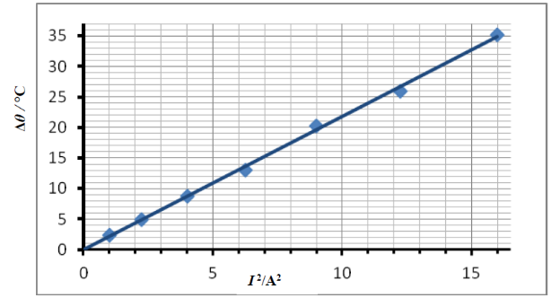
- How was the current changed during the experiment?
Adjust the (variable) power supply / (variable) resistor
I (A) | 1.0 | 1.5 | 2.0 | 2.5 | 3.0 | 3.5 | 4.0
I² (A²) | 1 | 2.25 | 4 | 6.25 | 9 | 12.25 | 16
Δθ (⁰C) | 2.3 | 4.9 | 8.8 | 13.0 | 20.2 | 26.0 | 35.2
- Complete the table
- Using the data in the completed table, draw a graph on graph paper of Δθ against I².
See graph
- Explain how your graph verifies Joule’s law.
Straight line through origin shows that Δθ α I² / P α I²
[2018 HL]
- Draw a diagram of the apparatus used in this experiment.
I (A) | 1.5 | 2.0 | 2.5 | 3.0 | 3.5 | 4.5 | 5.5
θ (°C) | 20.0 | 22.0 | 24.0 | 27.5 | 30.5 | 38.0 | 49.5
I² | 2.25 | 4.00 | 6.25 | 9.00 | 12.25 | 20.25 | 30.25
Δθ | 2.0 | 4.0 | 6.0 | 9.5 | 12.25 | 20.0 | 31.5
- Draw a suitable graph to verify Joule’s law.
Labelled axes,
6 points plotted correctly, straight line with good fit through the origin

- Calculate the slope of the graph and hence calculate the resistance of the heating coil.
Slope = 1.04
The slope of the graph corresponds to (Δθ/ I²) (assuming Δθ is plotted on the y-axis)
Electrical energy lost = heat energy gained
We now need to rearrange this so that we get R on one side and everything else on the other side.
RI² t = mcΔθ
Rt = mc(Δθ/I²)

$R=\frac{mc\left(slope\right)}{t}$=$\frac{(0.090)(4180)(1.04)}{180}$ R = 2.2 Ω

[2014 HL]
- Draw a labelled diagram of the apparatus used in the experiment.
A power supply, means of varying voltage, coil, ammeter in series, thermometer and coil in water
I² (A²) | 1 | 2.25 | 4 | 6.25 | 9 | 12.25
Δϴ (K) | 2.0 | 4.5 | 8.5 | 14.0 | 18.5 | 25.5
- Draw a suitable graph to verify Joule’s law.
six I² values calculated
axes labelled
6 points plotted
straight line with good fit
- Explain how the graph verifies Joule’s law.
straight line through origin / I² proportional to rise in temperature / P proportional to I²
- Estimate the highest temperature of the water . . .
I² = 2.56 highest temperature ≈ 25.3 °C
- Explain why a fixed mass of water was used.
(power required for) temperature rise is proportional to mass / otherwise there would be too many variables

SLOP

Give one use for electricity in the home. | Heating / cooking / lighting /named electrical appliance etc.
Effects of an electric current
List three effects of an electric current. | Magnetic effect, heating effect and chemical effect.
Describe an experiment that demonstrates the heating effect of an electric current. | Connect a electrical calorimeter containing water to a power supply and notice the increase in temperature using a thermometer.
State two factors on which the heating effect of an electric current depends. | Size of current, length of coil.
Describe how you would demonstrate the magnetic effect of an electric current. | See notes
Joule’s Law
Explain why high voltages are used in the transmission of electrical energy. | High voltages result in smaller currents therefore less energy is lost as heat.
Suggest a method of reducing the energy “lost” in ESB power lines. | Transfer the electrical energy at a higher voltage which would result in a lower current, therefore less energy lost as heat.
Fuses and Plugs
Name two safety devices that are used in domestic electric circuits. | Fuse, miniature circuit breaker, residual current device, earthing, 3 pin plug etc.
Give the standard colour of the insulation on the wires connected to each of the terminals L, N and E on the plug. | L (live) is brown, N (neutral) is blue, E (earth) is green-yellow
What is the purpose of the wire connected to the terminal E on the plug? | The earth wire protects from electrocution / shock by conducting the current to earth.
Name and give the colour of the wire that should be connected to the fuse in a standard three-pin plug. | Live, brown
Give one safety precaution that should be taken when wiring a plug. | Screw connections are fully tightened / fit the correct size fuse / ensure to match the colour codes
Explain why a fuse is used in a plug. | It ‘blows’ and breaks the circuit if too large a current flows, preventing possible electrocution.
Explain how a fuse works. | When too high a current flows the thin wire heats up and melts which breaks the circuit.
What will happen when a current of 20 A flows through a fuse marked 13 A? | The fuse blows which stops the current.
Why would it be dangerous to use a fuse with too high a rating? | It would allow too large a current to flow so the device could overheat.
The fuse in the plug of the kettle in the previous question was replaced with a 5 A fuse.  This current will only flow for a very short time. Explain why. | The current is larger than the fuse rating, so the fuse will blow.
Some electrical appliances are supplied with two-pin plugs. | They have a plastic housing so even if they are in contact with a live wire the current will not travel along the cover.
Why is an earth wire not required in these devices? | It is an insulator.
Why is the coating on electric cables made from plastic? | It is an insulator.
A toaster has exposed metal parts. How is the risk of electrocution minimised? | The metal parts are earthed.
Bonding is a safety precaution used in domestic electric circuits.  How does bonding improve safety in the home? | Bonding is where all metal pipes are connected to earth preventing accidental electrocution.
MCBs and RCDs
Name another device with the same function as a fuse. | Circuit breaker, trip switch, RCD, MCB
What is the purpose of a miniature circuit breaker (MCB) in an electric circuit? | It behaves as a fuse when too large a current flows
When will an RCD (residual current device) disconnect a circuit? | When the magnitude of the current flowing in is different from that flowing out.
An RCD is rated 30 mA. Explain the significance of this current. | The RCD trips the circuit if the current reaches 30 mA.
What is the purpose of a residual current device (RCD) in an electrical circuit? | It acts as a safety device by breaking the circuit if there is a difference between the live and the neutral in a circuit.
Name a device that is often used nowadays in domestic electric circuits instead of fuses. | Miniature circuit breakers (MCBs) or residual current devices (RCDs).
Give one advantage of a Residual Current Device (RCD) over a Miniature Circuit Breaker (MCB). | RCD responds v. Quickly, RCD responds to tiny currents
VI graphs and charge-carriers
What are the charge carriers when an electric current passes through an electrolyte? | Ions
Draw a graph to show the relationship between current and voltage for a metal at constant temperature | See graph
How would the VI graph for a metal differ if its temperature were increasing? | If temperature was increasing it would no longer be linear; instead there would be a curve to the right because resistance would increase.
Draw a graph to show the relationship between current and voltage for an ionic solution with inactive electrodes | Straight line starting at v > 0
How would the graph for the ionic solution differ if its concentration were reduced? | The slope of the graph would be less (the resistance increases) due to less ions (charge carriers) being present.
Draw a graph to show the relationship between current and voltage for a gas. | Axes, curve and plateau
The kilo-watt hour
What is the kilowatt-hour? | The kilo-watt hour is the amount of energy used by a 1000 watt appliance in one hour.
What is the function of the ESB meter? | It records the amount of units used.
Calculate the cost of the electricity used if each unit costs 15 cent. | Cost = 2 × 15 = 30 cent

VOLTAGE, CURRENT AND RESISTANCE EXAM QUESTIONS 2002 – 2023
Higher and Ordinary Level

Electric circuits – maths questions
2007 Question 12 (c) [Ordinary Level]
The circuit diagram shows two resistors connected in series with a 6 V battery.
- State Ohm’s law.
- Calculate the total resistance of the circuit.
- Calculate the current in the circuit.
- Calculate the potential difference across the 9 Ω resistor.
- Name an instrument used to measure potential difference.

2018 Question 9 (c) [Ordinary Level]
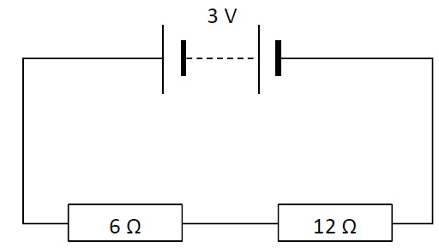
The circuit diagram shows two resistors connected in series with a 3 V battery.
- State Ohm’s law.
- Calculate the total resistance of the circuit.
- Calculate the current in the circuit.
- Calculate the potential difference across the 6 Ω resistor.
- Name an instrument used to measure potential difference.

2020 Question 12 (c) [Ordinary Level]
An electric current is a flow of electric charge.
A material that allows electric charge to flow through it is called an electrical conductor.
- Name a material that is an electrical conductor.
- What is the name given to a material that does not allow electric charge to flow through it?
- Describe an experiment to show that a material is an electrical conductor.
- Calculate the total resistance in the circuit shown above.
- Calculate the current flowing in the circuit.

2002 Question 8 [Ordinary Level]
- Explain potential difference
- Explain electric current.
- Give one difference between conduction in metals and conduction in semiconductors.
- A circuit consists of a 3 Ω resistor and a 6 Ω resistor connected in parallel to a 1.5 V d.c. supply as shown.
Calculate the total resistance of the two resistors.
- Calculate the current flowing in the circuit.
- What is the current in the 3 Ω resistor?
- Semiconductors can be made p-type or n-type.
How is a semiconductor made p-type?
- Draw a diagram showing a p-n junction connected in forward bias to a d.c. supply.
- Give two uses of semiconductors.
2008 Question 9 [Ordinary Level]
- An electric current flows in a conductor when there is a potential difference between its ends.
What is an electric current?
- Give two effects of an electric current.
- Name a source of potential difference.
- Describe an experiment to investigate if a substance is a conductor or an insulator.
- The two headlights of a truck are connected in parallel to a 24 V supply.
Draw a circuit diagram to show how the headlights are connected to the supply.
- What is the advantage of connecting them in parallel?
- Why should a fuse be included in such a circuit?
- The resistance of each headlight is 20 Ω.
Calculate the total resistance in the circuit.
- Calculate the current flowing in the circuit.

2016 Question 8 [Ordinary Level]
- Define voltage and resistance.
- Name an instrument used to measure each of these quantities.
- Name a source of voltage.
- The diagram above shows a circuit with a 12 V d.c. power supply, an ammeter, and two 4 Ω resistors connected in parallel.
Calculate the total resistance of the circuit
- Calculate the current flowing through the ammeter
- Calculate the current flowing through each resistor.
- One effect of an electric current is the heating effect. Name the two other effects of an electric
current.
- Describe an experiment to demonstrate one of these two effects.

2010 Question 9 (b) [Ordinary Level]
- State Ohm’s law
- The diagram shows a number of resistors connected to a 12 V battery and a bulb whose resistance is 4 Ω.
Calculate the combined resistance of the 15 Ω and 30 Ω resistors in parallel.
- Calculate the total resistance of the circuit
- Calculate the current flowing in the circuit

Question 9 (c) [Higher level]
- Derive an expression for the effective resistance of two resistors in parallel.

Three resistors X, Y and Z are arranged in a circuit as shown below.
- Calculate the current flowing in resistor X
- Calculate the current flowing in resistor Y

2023 Question 11 [Ordinary level]
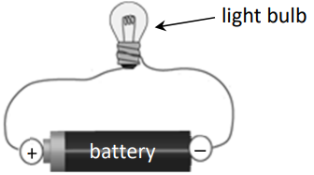
Electric current is the movement of charged particles through a conductor.
- What is an electrical conductor?
- Name an instrument used to measure electric current.
- Draw a circuit diagram for the arrangement of apparatus shown in the diagram on the right.
- Draw a circuit diagram to show two light bulbs connected in parallel across a battery.
Note: You may refer to the electrical circuit symbols on pages 72 to 78 of the Formulae and Tables booklet when answering parts (iii) and (iv).

- Two light bulbs connected in parallel have resistances of 5 Ω and 4 Ω.
Calculate the total resistance of the two light bulbs.
- Calculate the total current flowing in this circuit if the battery had a voltage of 12 V.

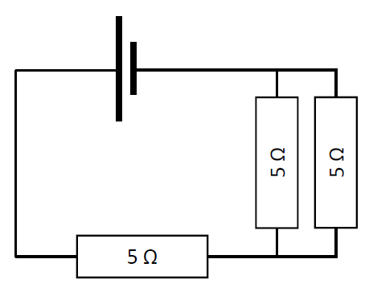
Question 14 (c) Higher Level 2023
A metal wire has length l, resistance R and cross‐sectional area A.
- State the relationship between R and A for the wire.
- Using an appropriate diagram, derive an expression for the effective resistance of two resistors R₁ and R₂ in series.
- Calculate the total resistance of the circuit shown.

- Describe how a fourth 5 Ω resistor could be added to the circuit so as to reduce the total effective resistance of the circuit.

2022 Question 11 [Ordinary Level]
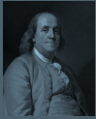
Benjamin Franklin began experimenting with electricity during the 18th century.
- What is electric current?
- Name an instrument used to measure electric current.
- A torch contains a battery, a light bulb and a switch.
Draw a circuit diagram to show how these components are connected in a torch.
(You may refer to the electrical circuit symbols on pages 72 to 78 of the booklet of Formulae and Tables.)
- The wires in a circuit are made of metal. Explain why.
- Name the subatomic particle that is the charge carrier in a metal.
- A charge of 30 C passes through a wire in a time of 6 s. Calculate the current flowing in the wire.
- The wire has a resistance of 3 Ω. Calculate the potential difference (voltage) across the wire.
- The 3 Ω wire is connected in parallel with another wire of resistance 2 Ω.
Calculate the total resistance of the two wires in parallel.
- A piece of wire of length 1.5 m has a resistance of 12 Ω.
What is the resistance of a 3 m piece of the same wire?
- State the relationship between the resistance of a wire and its cross‐sectional area.

2017 Question 8 [Higher Level]
- Distinguish between resistance and resistivity.
- What is the effect on the resistance of a length of wire if the diameter of the wire is increased by a factor of three?

In the circuit diagram shown, the a.c. supply has an rms voltage of 12 V.
The variable resistor is set at 500 Ω.
- What is meant by rms?
- What is meant by a.c.?
- Calculate the effective resistance of the circuit
- Calculate the current flowing in the 200 Ω resistor.

- The variable resistor is then removed.
What effect will this have on the current flowing in the 50 Ω resistor?
- Explain your answer.

Questions involving thermistors

2014 Question 12 (d) [Ordinary Level]
The circuit diagram shows a resistor and a thermistor connected in series with a 6 V battery.
At a certain temperature the resistance of the thermistor is 450 Ω.
- State Ohm’s law.
- What is the total resistance of the circuit?
- What is the current in the circuit?
- What is the potential difference across the 50 Ω resistor?
- What would happen to the resistance of the circuit if the temperature were increased?

2005 Question 8 [Ordinary Level]
- The circuit diagram shows a 100 Ω resistor and a thermistor connected in series with a 6 V battery.
At a certain temperature the resistance of the thermistor is 500 Ω.
Calculate the total resistance of the circuit.
- Calculate the current flowing in the circuit.
- Calculate the potential difference across the 100 Ω resistor.
- As the thermistor is heated, what happens to the resistance of the circuit?
- As the thermistor is heated, what happens to the potential difference across the 100 Ω resistor?
- Give a use for a thermistor.

2005 Question 9 [Higher Level]
- Define potential difference.
- Define resistance.
- Two resistors, of resistance R₁ and R₂ respectively, are connected in parallel. Derive an expression for the effective resistance of the two resistors in terms of R₁ and R₂.
- In the circuit diagram, the resistance of the thermistor at room temperature is 500 Ω.
At room temperature calculate the total resistance of the circuit.
- At room temperature calculate the current flowing through the 750 Ω resistor.
- As the temperature of the room increases, explain why the resistance of the thermistor decreases.
- As the temperature of the room increases, explain why the potential at A increases.

2022 Deferred Question 11 [Higher Level]
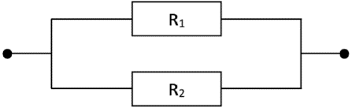
- Define potential difference.
- Define resistance.
- Derive an expression for the total effective resistance of resistors R₁ and R₂ shown in the diagram on the right.
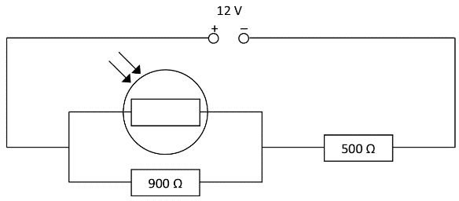
In the circuit diagram shown, the resistance of the LDR is 1.1 kΩ when light of a particular intensity falls on it.
- Calculate the total resistance of the circuit.
- Calculate the current flowing through the 900 Ω resistor.
- If the resistance of the LDR decreases, explain what happens to the potential difference across the 500 Ω resistor.

Resistivity
2021 Question 9 [Ordinary Level] edited
As electrons move through a metal, the metal resists this movement. The electrons collide with atoms of the metal and lose kinetic energy. This lost energy is converted into heat.
- Define resistance.
- Name the instrument used to measure resistance.
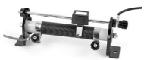
- The photograph shows a rheostat, which is a variable resistor.
When the sliding contact is moved, the current flows through a different length of wire, thus changing the resistance of the rheostat.
State the relationship between resistance and length.

A 4.8 m length of circular nichrome wire has a radius of 0.2 mm.
Nichrome has a resistivity of 1.1 × 10⁻⁶ Ω m.
- Calculate the circular cross‐sectional area of the wire.
- Calculate the resistance of the wire.

- Examine the circuit diagram shown on the right.
- Show that the combined resistance of the three resistors in parallel
(i.e. resistors R1, R2 and R3) is 1.05 Ω.
- Calculate the total resistance in the circuit.
- Calculate the current flowing through the ammeter, A.

2002 Question 8 [Higher Level] edited
- Define power.
- Define resistivity.
- The ESB supplies electrical energy at a rate of 2 MW to an industrial park from a local power station, whose output voltage is 10 kV.
The total length of the cables connecting the industrial park to the power station is 15 km. The cables have a diameter of 10 mm and are made from a material of resistivity 5.0 × 10⁻⁸ Ω m.
Calculate the total resistance of the cables.
- Calculate the current flowing in the cables.

2013 Question 8 (b) [Higher Level]
- Electricity generating companies transmit electricity over large distances at high voltage.
Explain why high voltage is used.
- A 3 km length of aluminium wire is used to carry a current of 250 A.
The wire has a circular cross-section of diameter 18 mm.
Calculate the resistance of the aluminium wire.
- Calculate how much electrical energy is converted to heat energy in the wire in ten minutes.
(resistivity of aluminium = 2.8 × 10⁻⁸ Ω m)

2008 Question 7 [Higher Level]
- Define resistivity and give its unit of measurement.
- A toaster’s heating coil is made of nichrome and it has a resistance of 12 Ω.
The coil is 40 m long and it has a circular cross-section of diameter 2.2 mm.
Calculate the resistivity of nichrome.

2010 Question 8 [Higher Level]
- Calculate the current that flows through the coil when the dryer is turned on.
- The maximum power generated in the heating coil is 2 kW.
What is the initial resistance of the coil?
- A length of nichrome wire of diameter 0.17 mm is used for the coil.
Calculate the length of the coil of wire.
(resistivity of nichrome = 1.1 × 10^{–6} Ω m)

Wheatstone bridge and metre bridge

2012 Question 9 [Higher Level]
- Define resistance.
- Two resistors of resistance R₁ and R₂ are connected in series.
Derive an expression for the effective resistance of the two resistors in terms of R₁ and R₂.
- Two 4 Ω resistors are connected in parallel.
Draw a circuit diagram to show how another 4 Ω resistor could be arranged with these two resistors to give an effective resistance of 6 Ω.
- A fuse is a resistor used as a safety device in a circuit. How does a fuse operate?

A Wheatstone bridge circuit is used to measure the resistance of an unknown resistor R.
The bridge ABCD is balanced when X = 2.2 kΩ, Y = 1.0 kΩ and Z = 440 Ω.

- What test would you use to determine that the bridge is balanced?
- What is the resistance of the unknown resistor R?
- When the unknown resistor R is covered by a piece of black paper, the bridge goes out of balance.
What type of resistor is it? Give a use for this type of resistor.

2014 Question 10 {second half}
- The resistance of the conductor in a strain gauge increases when a force is applied to it.
Strain gauges can act as the resistors in a Wheatstone bridge, and any change in their resistance can then be detected.
How would an observer know that a Wheatstone bridge is balanced?

The Wheatstone bridge in the diagram is balanced.

- What is the resistance of the unknown resistor?
- Write an expression for the resistance of a wire in terms of its resistivity, length and diameter.
- The radius of a wire is doubled. What is the effect of this on the resistance of the wire?

2007 Question 9 [Higher Level]
- Define resistance.
- Define resistivity.

A metre bridge was used to measure the resistance of a sample of nichrome wire.
The diagram indicates the readings taken when the metre bridge was balanced.
The nichrome wire has a length of 220 mm and a radius of 0.11 mm.

- Calculate the resistance of the nichrome wire
- Calculate the resistivity of nichrome.
- Sketch a graph to show the relationship between the temperature and the resistance of the nichrome wire as its temperature is increased.
- What happens to the resistance of the wire as its temperature falls below 0ºC?
- What happens to the resistance of the wire as its length is increased?
- What happens to the resistance of the wire if its diameter is increased?
- Name another device, apart from a metre bridge, that can be used to measure resistance.
- Give one advantage and one disadvantage of using this device instead of a metre bridge.

Effects of an electric current: Ordinary level questions

2012 Question 8 [Ordinary Level]
A plug is used to connect an electrical appliance in the home to the 230 volt mains supply.
Modern plugs contain a small fuse which comes with a rating of 1A, 2A, 3A, 5A or 13A.
The electrical energy supplied to the home is measured in kW h (kilowatt-hour).
- What is the colour of the wire that should be connected to the fuse in a plug?
- Why is there a fuse in a plug?
- Explain how a fuse works.

- A vacuum cleaner has a power rating of 900 W.
What is the most suitable fuse to use in the plug of the vacuum cleaner?
- Why is a fuse of a lower rating unsuitable?
- Name a device found in modern domestic circuits that has the same function as a fuse.
- If the vacuum cleaner is used for 90 minutes, calculate the number of units of electricity used.
- Calculate the cost of the energy used if the price of each unit of electricity is 22 cent.

2011 Question 12 (c) [Ordinary Level]
- What is an electric current, and give its unit of measurement?
- State the three effects of an electric current.
- How would you demonstrate one of the effects?
- An electric screwdriver has a power rating of 120 W when connected to its 24 V battery.
Calculate the current supplied by the battery when the screwdriver is turned on.

2010 Question 12 (c) [Ordinary Level]
The diagram shows a plug which contains a fuse, an MCB and an RCD, all of which are used in domestic circuits.
- Explain how a fuse works
- How does the fuse improve safety?
- What is an MCB?
- What is the function of an RCD?
- Why should an appliance be earthed?
- Give one other precaution that should be taken to improve safety when using electricity in the home.

2016 Question 12 (c) [Ordinary Level]
- A ring circuit is used in domestic wiring.
State one advantage of using of a ring circuit when wiring a house.
- Earthing is a safety measure included in domestic circuits.
What is meant by earthing?
- How does earthing contribute to safety?
- Name one other safety device used in domestic wiring.
- In a standard domestic three-pin plug, the live wire is covered in brown plastic.
Name the other two wires and state the colour associated with each of them.

2009 Question 8 [Ordinary Level]
Plugs are used to connect electrical appliances in the home to the 230 volt ESB supply.
Modern plugs contain a small fuse which comes with a rating of 1A, 2A, 3A, 5A or 13A.
The electrical energy supplied by ESB to the home is measured in kWh (kilowatt-hour).
- What is the colour of the wire that should be connected to the fuse in a plug?
- What is the function of a fuse?
- Explain how a fuse works.
- Name another device with the same function as a fuse.
- A coffee maker has a power rating of 800 W.
What is the most suitable fuse to use in the plug of the coffee maker?
- Why would it be dangerous to use a fuse with too high a rating?
- If the coffee maker was in use for 150 minutes:
Calculate the number of units of electricity used by the coffee maker.
- Calculate the cost of the electricity used if each unit costs 15 cent.

2006 Question 11 [Ordinary Level]
Read this passage and answer the questions below.
Electricity is so much part of modern living that we often take it for granted. It is a powerful and versatile energy of great use in the home but can be dangerous if not used properly. The electricity connection into your home comes through the ESB main fuse and the ESB meter. Almost all new electrical appliances now come complete with a fitted 13 Amp, 3-pin plug. Remember, a wrongly wired plug can result in a serious or fatal accident. The first thing to know is the colour code for connecting the cables to the appropriate pin/terminal in the plug. The cables consist of a metal conductor covered in coloured plastic.
When wiring a plug it is most important that all the screw connections are fully tightened. You should leave a little extra slack on the earth wire. You must also fit the correct size fuse. When an appliance is double insulated it does not need to be earthed. These appliances will only have two wires, the brown live and the blue neutral, they do not have an earth wire.
(Adapted from The Safe Use Of Electricity In The Home by The ESB.)
(a) Give one use for electricity in the home.
(b) What is the function of the ESB meter?
(c) What will happen when a current of 20 A flows through a fuse marked 13 A?
(d) Give one safety precaution that should be taken when wiring a plug.
(e) What is the colour of the earth wire in an electric cable?
(f) Name a common material used to conduct electricity in electric cables.
(g) Why is the coating on electric cables made from plastic?
(h) Why are some appliances not earthed?

2004 Question 9 [Ordinary Level]
- What is an electric current?
- An electric current can cause a heating effect. Name two other effects of an electric current.
- Describe an experiment to show the heating effect of an electric current.
- State two factors on which the heating effect of an electric current depends.
- An electric heater has a power rating of 2 kW when connected to the ESB mains supply of 230 V. Calculate the current that flows through the heater.
- What is the kilowatt-hour?
- Calculate the cost of using a 2 kW electric heater for 3 hours at 10 cent per kilowatt-hour.

2003 Question 8 [Ordinary Level]
- What is an electric current?
- Give the standard colour of the insulation on the wires connected to each of the terminals L, N and E on the plug in the diagram.
- What is the purpose of the wire connected to the terminal E on the plug?
- Explain why a fuse is used in a plug.
- The fuse in the plug of an electric kettle was replaced with a 5 A fuse. The kettle has a power rating of 2 kW when connected to the ESB mains voltage of 230 V.
Calculate the current that flows when the kettle is first plugged in.
- This current will only flow for a very short time. Explain why.
- Bonding is a safety precaution used in domestic electric circuits
How does bonding improve safety in the home?
- Name a device that is often used nowadays in domestic electric circuits instead of fuses.

2017 Question11 [Ordinary Level]
Read the following passage and answer the questions below.
The Electricity Connection to your Home
The electricity connection to your home is an a.c. supply and comes through ESB Networks’ main fuse and meter. The ordinary fuses or miniature circuit breakers in the distribution board respond to overloaded circuits by ‘blowing’ and switching off the flow of electricity in the circuit. Additional protection against electric shock or fire is provided by a Residual Current Device, RCD. In simple terms, an RCD detects an abnormal flow of electricity out of a circuit when, for instance, a cable is damaged or a fault develops in an appliance allowing electricity to ‘leak’ out. The RCD responds instantaneously to such ‘leakage’ and disconnects the supply from the circuit. All RCDs have a test button to check that the mechanism is working properly.
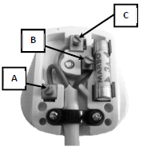
Making the Connection – Plugs and Cable Colours
Almost all new electric appliances now come complete with a fitted 13 A 3-pin plug. The first thing to know is the colour code for connecting the cables to the appropriate pin/terminal in the plug. When you connect each wire to the appropriate terminal, it is most important that no loose strands of wire are exposed and that all the screw connections are fully tightened. You should also leave a little extra slack on the green/yellow wire within the plug in order to avoid strain on this vital connection. The ordinary 13 A plug suits most of the commonly used ‘non-fixed’ appliances in the home – heaters, washing machines, dryers, microwave ovens, tools, entertainment equipment, etc. Appliances with a higher loading should be permanently connected to their own circuit through a switch. The most vulnerable parts of many appliances are the connecting flex and the plug. Most electrical accidents associated with electric appliances are caused either by damaged flexes or wrongly wired plugs. For your own safety, keep electric appliances well maintained and don’t abuse them.
(Adapted from The Safe Use of Electricity in the Home, ESB Networks)
(a) What is the function of the electricity meter?
(b) What is meant by the term a.c.?
(c) Name three safety devices found in domestic circuits.
(d) What is the cause of most accidents associated with electrical appliances?
(e) What is the function of the test button on an RCD?
(f) Name the pins labelled A, B and C in the diagram.
(g) State one precaution that should be taken when wiring a plug.
(h) What is the maximum power that an appliance with a 13 A plug can use when connected to a 220 V supply?

Voltage-current graphs for different conductors

2005 Question 8 (a) [Ordinary Level]
- State Ohm’s Law.
- The graphs show how current (I ) varies with potential difference (V) for
(a) a metal, (b) a filament bulb.
Which conductor obeys Ohm’s law?
- Explain your answer.

2013 Question 8 (a) [Ordinary Level]
- An electric current is the flow of charge in a conductor when there is a potential difference between its ends. Name the unit of current.
- Give an example of a conductor.
- Name a source of potential difference.
- What are the charge carriers in semiconductors?
- What type of conductor does the I-V graph in the diagram represent?

2019 Question 9 [Ordinary Level]
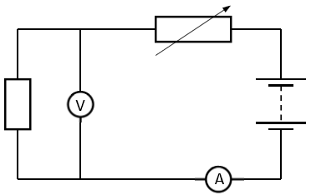
(a) The circuit on the right is used to demonstrate Ohm’s law.
- What is meter A?
- What is meter V?
- Which of the graphs below shows Ohm’s law being obeyed?
Explain your answer.

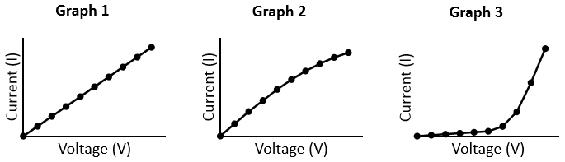

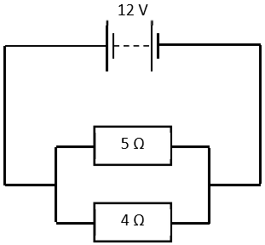

(b) In the circuit on the right, the resistors are wired in parallel.
- Calculate the total resistance in the circuit.
- Calculate the current flowing through the circuit.

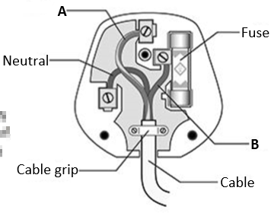
(c) The diagram on the right shows the parts of an electrical plug.

- Name the wire labelled A.
- Name the wire labelled B.
- State the function of the fuse.
- There are two other devices used in the distribution box of a domestic circuit that carry out a similar function to the fuse.
Name one of these devices.

2015 Question 12 (c) [Ordinary Level]
- Define resistance.
- What is the unit of resistance?
- Describe an experiment to demonstrate the heating effect of an electric current.
- Electrical conduction in different materials is due to the movement of charge carriers.
State the charge carriers that are responsible for conduction in each of the following.
- gases
- semiconductors
- metals
- solutions

2023 Question 11 [Ordinary level]
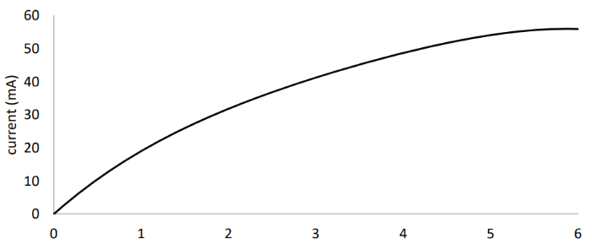
The relationship between current and voltage for a filament bulb is shown in the graph below.

- Explain the shape of the graph.
- Sketch the graph of current against voltage for a metallic conductor held at constant temperature.
- The charged particles that carry current through a metallic conductor are electrons. Name the charged particles that carry current through an ionic solution such as copper sulfate solution.

2003 Question 8 [Higher Level]
- Define the unit of current, i.e. the ampere.
- Describe an experiment to demonstrate the principle on which the definition of the ampere is based.
- Various materials conduct electricity. Draw a graph to show the relationship between current and voltage for each of the following conductors:
- a metal at constant temperature
- an ionic solution with inactive electrodes
- a gas.
- How would the graph for the metal differ if its temperature were increasing?
- How would the graph for the ionic solution differ if its concentration were reduced?

Effects of an electric current: Higher level questions

2006 Question 9 [Higher Level]
- What is an electric current?
- Define the ampere, the SI unit of current.
- Describe an experiment to demonstrate the principle on which the definition of the ampere is based.
- Sketch a graph to show the relationship between current and time for
  - alternating current;
  - direct current.
- The peak voltage of the mains electricity is 325 V. Calculate the rms voltage of the mains.
- What is the resistance of the filament of a light bulb, rated 40 W, when it is connected to the mains?
- Explain why the resistance of the bulb is different when it is not connected to the mains.

2002 Question 8 [Higher Level]
- The ESB supplies electrical energy at a rate of 2 MW to an industrial park from a local power station, whose output voltage is 10 kV.
The total length of the cables connecting the industrial park to the power station is 15 km. The cables have a diameter of 10 mm and are made from a material of resistivity 5.0 × 10⁻⁸ Ω m.
Calculate the total resistance of the cables.
- Calculate the current flowing in the cables.
- Calculate the rate at which energy is “lost” in the cables.
- Suggest a method of reducing the energy “lost” in the cables.

2011 Question 12 (c) [Higher Level]
- List the factors that affect the heat produced in a current-carrying conductor.
An electric cable consists of a single strand of insulated copper wire.
The wire is of uniform cross-sectional area and is designed to carry a current of 20 A.
To preserve the insulation, the maximum rate at which heat may be produced in the wire is 2.7 W per metre length.
- Calculate the maximum resistance per metre of the wire
- Calculate the minimum diameter of the wire.
(resistivity of copper = 1.7 × 10^{–8} Ω m)

2008 Question 7 [Higher Level]
- An electric toaster heats bread by convection and radiation.
What is the difference between convection and radiation as a means of heat transfer?
- A toaster has a power rating of 1050 W when it is connected to the mains supply.
Calculate the heat generated by the toaster in 2 minutes if it has an efficiency of 96%.
- The toaster has exposed metal parts. How is the risk of electrocution minimised?

2010 Question 8 [Higher Level]
A hair dryer with a plastic casing uses a coiled wire as a heat source.
When an electric current flows through the coiled wire, the air around it heats up and a motorised fan blows the hot air out.
- What is an electric current?
- Heating is one effect of an electric current.
Give two other effects of an electric current.
- The diagram shows a basic electrical circuit for a hair dryer.
Describe what happens when switch A is closed and the rheostat is adjusted
- Describe what happens when switch A and switch B are closed.
- Explain why the current through the coil would decrease if the fan developed a fault and stopped working.

2022 Deferred Question 13 [Higher Level]
Read the following passage and answer the accompanying questions.
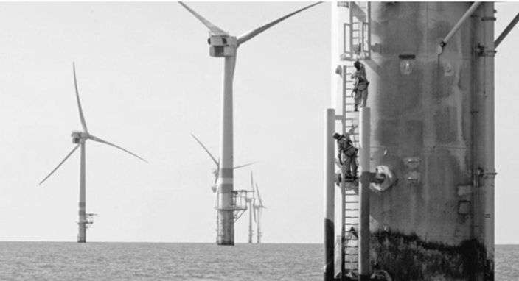
Off‐shore wind farms are making electricity suppliers look again at high‐voltage d.c. transmission to reduce operating costs. Out at sea, turbine blades turn more quickly than on land thanks to faster, more stable winds. This means that power generation shoots up because it is governed by the cube of the airstream’s velocity. The power capacity of the largest offshore turbines is currently 5 MW whereas on land it is 3 MW.

To make best use of the energy generated at sea, it must be transmitted back to the mainland in an efficient manner. For this reason the power must be transmitted to land at a very high voltage. Where turbines are more than about 80 kilometres from shore, a.c. transmission is not viable, due to very large energy losses in the transmission system.

The alternative is high‐voltage d.c. transmission. This was used in the cross‐channel link between Britain and France in the last century. More recently, China has been developing the use of high voltage d.c. to transmit electrical energy between generating stations and cities.
However transmitting electricity at high voltages places greater demands on the reliability of insulating materials used in these electrical transmission systems.
Adapted from Physics World Focus on Nanotechnology, June 2013

  - How do a.c. and d.c. differ?
  - A wind turbine has a power output of 200 kW when the wind speed is 10 m s^{–1}.
Calculate the power of the turbine when the wind speed increases to 15 m s^{–1}.
  - The average power output of a wind turbine over a period of one year was 300 kW.
Calculate the number of units of electrical energy generated by the turbine in that year.
  - The conversion of a.c. to d.c. is required for high‐voltage d.c. transmission.
Name the term used to describe this conversion.
  - Draw the electrical circuit symbol for the semiconductor device used in this process.
  - The peak a.c. voltage generated by a particular wind turbine is 690 V. Calculate the rms voltage generated.
  - The average power generated by the wind turbine described in part (e) is 1.5 MW. Calculate the rms current generated.
  - Explain why a very high voltage is required for the efficient transmission of electricity.
  - Name a material that is an electrical insulator. State one reason why an insulator is needed in the transmission of electricity.

EXAM SOLUTIONS: ORDINARY LEVEL MATHS QUESTIONS

2002 Question 8 [Ordinary Level]
- Explain potential difference.
The Potential difference between two points is the work done in bringing a charge of 1 Coulomb from one point to the other.
- Explain electric current.
An electric current is a flow of charge.
- Give one difference between conduction in metals and conduction in semiconductors.
There are two types of charge carriers (holes and electrons) in semiconductors, whereas with metals electrons are the only charge carriers.
Conduction increases with temperature for semiconductors whereas conduction decreases with temperature for metals.
- A circuit consists of a 3 Ω resistor and a 6 Ω resistor connected in parallel to a 1.5 V d.c. supply as shown. Calculate the total resistance of the two resistors.
1/R = 1/3 + 1/6 1/R = 1/2 R = 2 Ω.
- Calculate the current flowing in the circuit.
V = IR I = V/R I = 1.5/2 = 0.75 A
- What is the current in the 3 Ω resistor?
Voltages in parallel are the same and the supply voltage is in parallel with the 3 Ω resistor, so the voltage across the 3 Ω resistor is also 1.5 Volts I = 1.5/3 = 0.5 A
- Semiconductors can be made p-type or n-type. How is a semiconductor made p-type?
By doping it with Boron.
- Draw a diagram showing a p-n junction connected in forward bias to a d.c. supply.
- Give two uses of semiconductors.
Rectifiers, transistors, diodes, thermistors, thermometers, radios/TV, etc.

2003 Question 8 [Ordinary Level]
Calculate the current that flows when the kettle is first plugged in.
P = VI I = P/V I = 2000/230 = 8.7 A

2004 Question 9 [Ordinary Level]
Calculate the current that flows through the heater.
P = VI ⇒ I = P/V ⇒ I = 2,000/230 = 8.7 A.

Calculate the cost of using a 2 kW electric heater for 3 hours at 10 cent per kilowatt-hour.
Number of kiloWatt hours = Number of kilowatts x Number of Hours
= 2 × 3 = 6 kW hrs.
Cost = 6 × 10 = 60 cent

2005 Question 8 [Ordinary Level]
- State Ohm’s Law.
Ohm’s Law states that the current flowing through a conductor is directly proportional to the potential difference across it, assuming constant temperature.
- Which conductor obeys Ohm’s law?
The metal.
- Explain your answer.
Graph (a) results in a straight line through the origin, therefore I is proportional to V
- Calculate the total resistance of the circuit.
R_{Total} = R₁ + R₂ ⇒ R_{Total} = 100 + 500 = 600 Ω.
- Calculate the current flowing in the circuit.
V = I R ⇒ I = V/R ⇒I = 6/600 = 0.01A
- Calculate the potential difference across the 100 Ω resistor.
V = I R  V = (0.01)×(100) V = 1 V.
- As the thermistor is heated, what happens to the resistance of the circuit?
It decreases.
- As the thermistor is heated, what happens to the potential difference across the 100 Ω resistor?
It increases, because the total voltage is still 6 V is still the potential difference across both resistors, so if the potential difference decreases across the thermistor, it must increase across the 100 Ω resistor.
- Give a use for a thermistor.
Thermometer, heat sensor, temperature control.

2007 Question 12 (c) [Ordinary Level]
- State Ohm’s law.
Ohm’s Law states that the current flowing through a conductor is directly proportional to the potential difference across it, assuming constant temperature.
- Calculate the total resistance of the circuit.
R = 3 + 9 = 12 Ω
- Calculate the current in the circuit.
V=IR ⇒ I = V/R = 6/12 = 0.5 A
- Calculate the potential difference across the 9 Ω resistor.
V = I R = 0.5×9 = 4.5 V
- Name an instrument used to measure potential difference.
A voltmeter

2008 Question 9 [Ordinary Level]
(v) The two headlights of a truck are connected in parallel to a 24 V supply.
Draw a circuit diagram to show how the headlights are connected to the supply.
Circuit diagram showing battery and two bulbs connected in parallel.
- What is the advantage of connecting them in parallel?
If one goes the other still works, they are brighter.
- Why should a fuse be included in such a circuit?
To prevent too high a current flowing.
- The resistance of each headlight is 20 Ω. Calculate the total resistance in the circuit.
For resistors in parallel we use the formula:
R = 10 Ω

- Calculate the current flowing in the circuit.
V = IR I = V/R I = 24/10 = 2.4 A.

2009 Question 8 [Ordinary Level]
What is the most suitable fuse to use in the plug of the coffee maker?
P = VI I = P/V = 800/230 = 3.4 A
So the most suitable fuse is the 5 A fuse.

If the coffee maker was in use for 150 minutes calculate the number of units of electricity used by the coffee maker.
Power = 800 W = 0.8 kW Time = 150 minutes = 2.5 hours
Number of kilowatt hours = Number of kilowatts × Number of Hours.
= 0.8 × 2.5 = 2 kWh

Calculate the cost of the electricity used if each unit costs 15 cent.
Cost = 2 × 15 = 30 cent

2010 Question 9 (b) [Ordinary Level]
- State Ohm’s law
Ohm’s Law states that the current flowing through a conductor is directly proportional to the potential difference across it, assuming constant temperature.
- Calculate the combined resistance of the 15 Ω and 30 Ω resistors in parallel.
$\frac{1}{R_{15,30}}= \frac{1}{15}+ \frac{1}{30}$ $\frac{1}{R_{15,30}}= \frac{1}{10}$ R_{15,30} = 10 Ω

- Calculate the total resistance of the circuit: Total resistance of the circuit = 10 + 10 + 4 = 24 Ω.

- Calculate the current flowing in the circuit
$R= \frac{V}{I}$ $I_{total}= \frac{V_{total}}{R_{total}}$ $I_{total}= \frac{12}{24}$ $I_{total}=0.5 A$

2011 Question 12 (c) [Ordinary Level]
Calculate the current supplied by the battery when the screwdriver is turned on.
P = IV 120= (I)(24) I = 5 A

2012 Question 8 [Ordinary Level]
What is the most suitable fuse to use in the plug of the vacuum cleaner?
P = VI I = P/V = 900/230 = 3.9 amps
The most suitable fuse is the one with a current rating just above 3.9 amps so a 5 amp fuse should be used.

If the vacuum cleaner is used for 90 minutes, calculate the number of units of electricity used.
Power = 900 W = 0.9 kW Time = 90 minutes = 1.5 hours
Number of kiloWatt hours = number of kilowatts × number of hours.
= (0.9)( 1.5) = 1.35 kiloWatt hours

Calculate the cost of the energy used if the price of each unit of electricity is 22 cent.
Cost = (1.35)(22) = 29.7 cent / 30 cent

2013 Question 9 (b) [Ordinary Level]
- State Ohm’s law.
The current through a conductor is directly proportional to the voltage
- Calculate the total resistance of the circuit.
6 + 12 = 18 Ω
- Calculate the current in the circuit.
I = $\frac{V}{R}= \frac{3}{18}$ = 0.166 A
- Calculate the potential difference across the 6 Ω resistor.
V = IR = (0.166)(6) = 1 V
- Name an instrument used to measure potential difference.
Voltmeter

2013 Question 12 (d) [Ordinary Level]
- State Ohm’s law.
Ohm’s Law states that the current flowing through a conductor is directly proportional to the potential difference across it, assuming constant temperature.
- What is the total resistance of the circuit?
500 (Ω)
- What is the current in the circuit?
I = V/R = 6/500 = 1.2 × 10⁻³ A
- What is the potential difference across the 50 Ω resistor?
V = IR = (1.2 × 10⁻³)(50) = 0.6 V
- What would happen to the resistance of the circuit if the temperature were increased?
It would decrease

2017 Question 11 [Ordinary Level]
What is the maximum power that an appliance with a 13 A plug can use when connected to a 220 V supply?
P = IV = 13 × 220 = 2860 W

2019 Question 9 [Ordinary Level]
Calculate the total resistance in the circuit.
$\frac{1}{R_{Total}}= \frac{1}{R_{1}}+ \frac{1}{R_{2}}$ $\frac{1}{R_{Total}}= \frac{1}{5}+ \frac{1}{4}$ R_{P} = 2.2 Ω

Calculate the current flowing through the circuit.
V = IR I = V ÷ R I = 12 ÷ 2.2 = 5.4 A

2022 Question 11 [Ordinary Level]
- What is electric current?
flow of charge
- Name an instrument used to measure electric current.
ammeter /galvanometer / multimeter
- Draw a circuit diagram to show how these components are connected in a torch.
component symbols [3 × 1] connected in series
- The wires in a circuit are made of metal. Explain why.
conductor
- Name the subatomic particle that is the charge carrier in a metal.
electron
- Calculate the current flowing in the wire.
30 ÷ 6 = 5 A
- Calculate the total resistance of the two wires in parallel.
5 × 3 = 15 V
- What is the resistance of a 3 m piece of the same wire?
1/R₁ + 1/R₂ = 1/R_{Total}
substitution
R_{Total} = 1.2 Ω
- What is the resistance of a 3 m piece of the same wire?
24 Ω / double
- State the relationship between the resistance of a wire and its cross‐sectional area.
They are inversely proportional

Voltages in series: Imagine you’re lifting a book up to the second step on a stairs. If it takes 10 joules to lift it to the first step and another 10 joules to lift it from the first step to the second step then we can say that the total work done is 20 joules. It’s the same when work is done moving charge through two resistors. Except that when we talk about the work done in moving charge we refer to it as potential difference. The total work done is the work done bringing the charge through the first resistor (V₁) plus the work done bringing the charge through the second resistor (V₂).
Voltages in parallel are the same This is a constant source of confusion for students and indeed I suspect for many teachers. Allow me to try and clarify. Consider two resistors in parallel: R₁ is 100 ohms and is in parallel with R₂ which is a 20 ohm resistor. The current in the 20 ohm resistor will be five times greater than the current in the 100 ohm resistor. To calculate the voltage across each resistor, we multiply the resistance by the current (from V = RI), and find that the voltage across both is the same. It should now be obvious why: If the resistance goes up by a factor of five, the current will go down by the same factor therefore mathematically the product of resistance and current (i.e. the voltage) will be constant. The confusion arises because you would think that the bigger resistor would require more work to push charge through. This would indeed be the case if the same current was passing through both resistors but as we have just seen, this will not be the case if they are in parallel. Clear as mud??
Because voltages in parallel are the same.
You know that potential difference (voltage) is the work done in bringing charge from one point to another, e.g. across a resistor or some other apparatus. Well if we wish to bring a charge around an entire circuit, i.e. from one terminal to the other, possibly passing through a number of resistors and other devices along the way then we express the total potential difference as ‘the emf’ of the circuit. It could also be the case that the circuit is not complete, in which case the emf would represent the work which would be done in bringing charge from one point to another if it was a complete circuit.
A conductor is a substance which allows charge to flow through it easily. You may have learned previously that an insulator is a material that doesn’t allow charge to flow through it but it turns out that even a good insulator like plastic will conduct charge if there is a big enough potential difference between the two sides. Air is normally a good insulator but again it can become a conductor if the conditions are right. That’s when we get lightning. A concept that we don’t appreciate sufficiently is the fact that we are electrical machines. Electrical signals are continuously passing from every cell in our body to nearby cells or to our brains so it shouldn’t be surprising that external electrical current can interfere with this. We can just about feel a tingle if there is a continuous current of approximately 1 mA while 10 – 20 mA will interfere with our muscle function to the extent that that we can’t relax the muscle even if we want to. 50 – 200 mA of continuous current flow will prevent the heart from functioning as it needs to, resulting in death.
Electric current is a measure of the rate of flow of charge. The term in italics is important. Defining current as a flow of charge is therefore not correct, despite what some textbooks might say.
The symbol for current is I: Why is I used to represent current? From “intensité de courant”, meaning current intensity; the term current was later used to signify that something was flowing. However they couldn’t use C for current as it had already been requisitioned to represent capacitance. It seems to me that to define current as a flow of charge is incorrect; current should be a measure of the rate of flow of charge; the greater the current, the more charge that’s flowing per second.
Think ‘QuIt’
Conventional Current: We mentioned Benjamin Franklin in the chapter on Static Electricity; he was the dude who labelled electricity as positive and negative, and believed that both types of charge were mobile. It was also he who promoted the notion that positive charge flowed from the positive end of a battery to the negative end. We know better now, but once again scientists in their infinite wisdom decided to keep this erroneous convention, so today in textbooks we represent current as going from positive to negative, whereas in reality (for a metal) it is actually the negative electrons which are going from the negative terminal to the positive.
Electricians don’t use ammeters; they use multimeters which measure current, voltage, resistance together with other quantities.
In series means in line or on the same line as the current itself.
The current is the same at every point in a series circuit. There are a number of different analogies to help students understand current. The one which I find to be most useful for this concept is as follows; Imagine a small race circuit, the track is completely filled with cars bumper to bumper. There is now no way that any one part of the circuit can move more quickly than another, so if you can calculate how many cars are passing a given point in one second you know that this is the same for all parts of the circuit – it’s the same for electrons in an electric circuit. Now if any individual car meets with resistance and has to slow down, so naturally do all the cars behind, but because the circuit is complete, even the cars in front have to slow down to the pace of the slowest car behind them.
The sum of the currents flowing into a junction is equal to the sum of the currents leaving the junction. Picture three streams flowing into one lake. Let’s say coming out of this lake are two other streams. Now if the size of the lake isn’t getting bigger or smaller then the total amount of water flowing into the lake must equal the total amount of water flowing out. It’s the same for current. An analogy to help you understand the flow of the electrons caused by potential difference is to imagine pushing a stiff bicycle chain around and around.Each link is an electron, and they all move at the same speed. It’s not a bad analogy, but like all analogies it has its limitations; can you see why this one isn’t perfect?
Ohm’s Law Remember from Junior Cert that a resistor was defined as something which resists the flow of current? Well in Leaving Cert Physics we like to quantify things (that means put numbers on them), hence the formula. If you think about it the formula does make sense, because if V is small (think of it as exerting just a small effort to push the electrons through) and you find that the current (I) is large, it implies that there couldn’t have been much resistance in the circuit, i.e. if the ratio of voltage to current is small, so is the resistance. Similarly, if you use a lot of energy to try and push the electrons through (V is large), and yet you still only get a small current (I is small), this suggests that there must be a large resistance in the circuit, i.e. if the ratio of voltage to current is large, so is the resistance. “What power! To condense all the meaning in that long sentence into a simple four symbol equation. That is the art of our science.”
“at constant temperature” If you omit the phrase ‘at constant temperature’ you may lose 3 marks out of the total 6. In practice most metals heat up when a current passes through them which means that the resistance increases. This is because the atoms in the metal gain energy and ‘jiggle’ up and down, making it harder for any free electrons to travel through the material.
Note that Ohm’s law only applies to certain substances. In fact even calling it a law is a bit generous. A law in science is something that is very wide ranging, whereas Ohm’s law only applies to some metals (and not to gases) and only if the temperature is kept constant, but passing a current through a material usually increases the temperature anyway, so Ohm’s law is more of an approximation than a law. Or to put it another way, “Resistance is futile and varies with temperature”.
You will not need to consider anything as complex as the diagram on the right, but can you see why it makes more sense to use symbols than images of actual components?
For both derivations, the first line is crucial. Ask yourself what quantity is same both for the total and for the sub-parts and make that your starting point. So for resistors in series the first line involves current and for resistors in parallel the first line involves potential difference. Secondly, each derivation must include a diagram with all the R’s, V’s and I’s clearly indicated.
Have you noticed that the total resistance of two resistors in parallel is actually less than the resistance of either resistor on its own. No? Well let’s pretend you have (otherwise there really wouldn’t be much point with me continuing with this). The confusion arises partly because we associate resistance with slowing down the motion of electrons, so two resistors should result in a greater ‘slowing down effect’ than one resistor. And this is correct – but only if the resistors are arranged in series. If they are arranged in parallel the effect is completely different. Imagine one resistor to be like a turnstyle gate which slows the motion of hundreds of fans as they enter a football stadium. Now imagine a second turnstyle gate is opened up beside the first one. Essentially we have opened up a second pathway and no matter how hard it is to get through that second turnstyle it is still better to have it than not have it – therefore the overall resistance of the system goes down. So when we add a second resistor in parallel we are actually adding another pathway. For homework see if you can come up with two more analogies for this effect. Another expression of the formula for the effective resistance of resistors in parallel is simply product over sum written as: R_{Effectice} = (R₁ × R₂)/(R₁ + R₂). As an exercise you could show how both expressions are equivalent. It has the advantage of not needing to get the reciprocal at the end (which is something that students often forget to do anyway). By the way, what do you get if you leave a resistor on the stove? An ohm on the range.
Why do we have a concept called ‘resistivity’? Because you can’t just say that ‘the resistance of copper is 3 ohms’; you would need to specify the length and the width of the material. It’s similar to the reason why we have the concept of density. It wouldn’t make any sense to say that iron is heavier than paper because you might have a tiny piece of iron and a very large piece of newspaper). What we mean when we say that iron is heavier than paper is ‘if we had the same volume of both, then the iron would have a greater mass’. Density is a shorthand way of saying this. In a similar way, saying that the resistivity of copper is greater than that the resistivity of silver is shorthand for saying; ‘If the two materials are of equal length and equal cross-sectional area, then the sample of silver would have a greater resistance than the sample of copper’.
Because an object which is 1 m long and has a cross-sectional area of 1 m² is actually a cube of side 1 metre.
To help you remember the formula: the ratio of the first to the second resistance on one line is equal to the ratio of first to second resistance on the second line. A galvanometer connects the center of one line to the center of the other.
The values of the four resistors shown are arranged (by trial and error) so that there is no voltage between points D and B. If there is no voltage between D and B then no current will flow between those points so any current flowing through R₁ will also flow through R₂ and any current flowing through R₃ will also flow through R₄ (or R_{x}) in this case. A galvanometer is used to measure this voltage (indicated as V_{G} in the diagram). The bridge is now said to be balanced. Why do you need a potential difference for current to flow? Here’s one way to consider it; there has to be a difference for something to happen, so you need a height difference to make water to flow, potential difference to make current to flow etc.
R₁ is proportional to l₁. R₂ = kl₁. R₂ is proportional to l₂. Therefore $\frac{R_{1}}{R_{2}}=\frac{{kl}_{1}}{{kl}_{2}}$ We can cancel k to leave us with $\frac{R_{1}}{R_{2}}=\frac{l_{1}}{l_{2}}$
W = I² Rt This means that: W ∝ I² (if t and R are fixed) W ∝ R (if I and t are fixed) W ∝ t (if I and R are fixed)
Let’s use some examples: If the current goes up by a factor of 2 (“doubles”), the heat produced goes up by a factor of 2² (gets 4 times bigger). If the current goes up by a factor of 3 (“triples”) the heat produced will go up by a factor of 3² (gets 9 times bigger).
Why is electrical energy transmitted using high voltage power lines? These voltages are then lowered before they enter a town, using transformer stations, and are lowered even more (to 220 volts) using a transformer outside your ouse. Every three or four houses have their own transformer. Now each time the voltage is lowered, the current is raised, but now at least it’s only for a short distance. All of your electrical appliances at home which plug into the mains have transformers inside them which reduce the voltage further still, often to as low as 9 or 12 volts.
Why do we have this concept? One kilowatt-hour is equivalent to 3600000 joules so the numbers on your electricity bill would simply be too big if they were left in joules.

